- All new vocabulary will be displayed on Working Walls in the classroom environment.  - WAGOLL to use for whole class teaching demonstrating the skills and vocabulary expectations. |  |  |  |  | - Learning is progressive and therefore texts and skills need to be taught in chronological order.  - New ambitious vocabulary will be introduced and pre taught by staff weekly using a range of adjectives, verbs, nouns, adverbs.
Autumn 1
History - The Census |  |  |  |  |  |  |  |  |  |  | Science - Materials
Text and Genre | Retell - Leather Shoe Charlie   |  |  | Character Description   |  |  |  | Setting Description- |  | Retell- chapter 14?   | Instructions
Year 5 Genre Progression | Describe setting, characters and atmosphere.  Describe the character and include their feelings using show don’t tell. Use show don’t tell to build suspense. Use short sentences for tension. Cliff hanger questions.  Use dialogue to convey a character and advance the action.  Use organisational and presentational devices that are relevant to the text type, for example, underlining / uppercase. |  |  | Written in the past or present tense.  Describe the character and included their feelings by using show don’t tell.  Including speech and moving the action on. |  |  |  | Include two adjectives in my fronted adverbial of place.  “Under the ancient, crumbling bridge,”  Using rich description to interest the reader such as metaphors, personification, and onomatopoeia |  | Describe setting, characters and atmosphere.  Describe the character and include their feelings using show don’t tell. Use show don’t tell to build suspense. Use short sentences for tension. Cliff hanger questions.  Use dialogue to convey a character and advance the action.  . | Informal / formal instructions could be humorous or formal.  Hook the reader in the introduction  Sophisticated / appropriate use of adverbs / adjectives  Awareness of the audience  Add a recommendation  Use organisational and presentational devices that are relevant to the text type, for example, underlining / uppercase
Year 6 Genre Progression | Author’s style of writing and use appropriate author’s voice  Consider purpose and audience  Changing tenses – flashback |  |  | Written in the past or present tense.  Describe the character and included their feelings by using show don’t tell.  Including speech and moving the action on. |  |  |  | Power of three fronted adverbials  Personification of the weather  Evocative language to create a mood, strong feelings, memories, or emotions back  Consider the audience, purpose and write using the appropriate author’s voice |  | Author’s style of writing and use appropriate author’s voice  Consider purpose and audience  Changing tenses – flashback | Develop an introduction – add background.  If appropriate add personal advice using parentheses.  Select own title, headings and presentational devices  Use pictures, diagrams, flow charts and symbols (if appropriate) to present information independently  Use brackets to add asides  Author’s style of writing and use appropriate author’s voice.  Consider purpose and audience.
Handwriting –Adapt handwriting style according to the purpose of the writing.
Year 5  Grammar and Punctuation | Understand the importance of cohesion in my writing in fiction writing. I use place, time or manner adverbials to ensure cohesion in and across paragraphs.  (One conjunction per sentence.)  Include complex sentences, which start with a subordinating conjunction followed by a comma.  Use ISPACED (ing word, simile, preposition, adverb, conjunction, -ed word, dialogue) to open a sentence.  Include direct speech in my stories but changing where the reporting clause is in the sentence (beginning, middle, end). |  |  | Use more sophisticated metaphors to describe things in my writing.  Use noun phrases with a modifier, choosing words carefully to really ‘show’ the reader what I am describing. |  |  |  | Use personification.  Use ISPACED (ing word, simile, preposition, adverb, conjunction, -ed word, dialogue) to open a sentence. |  | In narratives describing settings, characters and atmosphere and integrating dialogue to advance the action. | Use a colon to introduce a list within a sentence.
Year 6 Grammar and Punctuation | Understand the importance of cohesion in my writing in fiction writing. I use place, time or manner adverbials to ensure cohesion in and across paragraphs.  Use commas to demarcate relative clauses, reporting clauses, embedded clauses and to separate the subordinate clause from the main clause where the subordinate clause comes first.  Inverted commas and other punctuation to indicate direct speech. |  |  | In narratives, describe settings, characters and atmosphere. |  |  |  | In narratives, describe settings, characters and atmosphere.  Use a range of figurative language (metaphors, onomatopoeia, personification). |  | Make purposeful choices with adverbs, adjectives, ENPs and adverbials to make writing more descriptive.  Use simple sentences to build tension. | Use sentences with lists to give a number of pieces of information succinctly (e.g., component parts, features of locations…)  Use colons to introduce a list and punctuate bullet points consistently.
Autumn 2
Science Living Things (Y5)
Geography Population(Kapow Cycle B)
Text and Genre | Retell | Retell |  | Rolling news |  |  |  |  |  | Excitable Edgar
Year 5  Genre Progression | Describe setting, characters and atmosphere.  Describe the character and include their feelings using show don’t tell. Use show don’t tell to build suspense. Use short sentences for tension. Cliff hanger questions.  Use dialogue to convey a character and advance the action.  Use organisational and presentational devices that are relevant to the text type, for example, underlining / uppercase. | Describe setting, characters and atmosphere.  Describe the character and include their feelings using show don’t tell. Use show don’t tell to build suspense. Use short sentences for tension. Cliff hanger questions.  Use dialogue to convey a character and advance the action.  Use organisational and presentational devices that are relevant to the text type, for example, underlining / uppercase. |  | Indirect speech.  Verbs selected for meaning and effect.  Precise vocabulary choices. Paragraphs and caption.  Journalistic words and phrases.  By-line (who wrote it).  Rhetorical questions. . |  |  |  |  |  | Introduce the debate with background information.  Argument for the issue with supporting evidence.  Argument against the issue with supporting evidence.  Phrases of debate.  Facts and statistics.  Technical vocabulary.  Passive voice.
Year 6 Genre Progression | Author’s style of writing and use appropriate author’s voice  Consider purpose and audience  Changing tenses – flashback | Author’s style of writing and use appropriate author’s voice  Consider purpose and audience  Changing tenses – flashback |  | Précis key events Lead the reader to reflect on the events  Appropriate presentation Reconstruct, interpret and communicate events  Passive voice First-hand accounts Paints a vivid and dramatic picture Distinctive voices of individuals  Thoughtful ending  Closing editorial comment adapts a more personal stance
Handwriting –Adapt handwriting style according to the purpose of the writing.
Year 5  Grammar and Punctuation | Adding a new line whenever a new person starts speaking.  Use speech within a piece of writing to move the story on. | Use show don’t tell to build suspense, to introduce a dilemma in a story and convey a character’s emotions. |  | Use relative clauses beginning with who, which, where, when, whose, that or with an implied (i.e. omitted) relative pronoun. |  |  |  |  |  | Ask a rhetorical question to appeal directly to the reader.  Include complex sentences, which start with a subordinating conjunction followed by a comma.  Link sentences and paragraphs using coordinating and subordinating conjunction.
Year 6 Grammar and Punctuation | Integrate dialogue to convey character and advance the action. | Integrate dialogue to convey character and advance the action. |  | Use commas to demarcate relative clauses, reporting clauses, embedded clauses and to separate the subordinate clause from the main clause where the subordinate clause comes first.  Use the passive voice to make the object more important in the sentence than the subject. |  |  |  |  |  | Use commas to demarcate relative clauses, reporting clauses, embedded clauses and to separate the subordinate clause from the main clause where the subordinate clause comes first.  Use adverbials to introduce an argument (Firstly).  Use adverbials to form links between arguments and develop arguments, to signal an illustration of a proceeding point.  Use linking adverbs to show opposition or a counter argument.  Use adverbials to introduce a concluding paragraph (Having considered all of the arguments… In Summary, To conclude,).  Use adverbials in different places in a sentence (On one hand…. whereas/yet/however…).
Spring 1
Greeks
Animals
Text and Genre | Diary Entry |  |  | Retell  Opening scene from Percy Jackson and the Lightning Thief   |  |  |  | Retell |  | Biography-
Year 5  Genre Progression | Past perfect tense.  Organised into paragraphs, with the day’s events developed and expanded through descriptive detail.The opening locates the events precisely in time and the piece concludes by looking ahead to the following day.  Language choices to reflect the theme (historical etc.).  Include a quote.  Move between tenses within paragraphs – own choice. |  |  | Describe setting, characters and atmosphere.  Describe the character and include their feelings using show don’t tell. Use show don’t tell to build suspense. Use short sentences for tension. Cliff hanger questions.  Use dialogue to convey a character and advance the action.  Use organisational and presentational devices that are relevant to the text type, for example, underlining / uppercase. |  |  |  | Describe setting, characters and atmosphere.  Describe the character and include their feelings using show don’t tell. Use show don’t tell to build suspense. Use short sentences for tension. Cliff hanger questions.  Use dialogue to convey a character and advance the action.  Use organisational and presentational devices that are relevant to the text type, for example, underlining / uppercase. |  | Key influences in the person’s life, (their relationship with other. people and who inspired them).  Historical famous characters. Link to whole school theme / local hero.
Year 6 Genre Progression | Multiple entries  Include suspense  Changing moods and emotions  Maintaining tense and writer’s voice  Subjunctive form  Active and passive voice  Formality for effect  Consider the audience, purpose and write using the appropriate author’s voice |  |  | Author’s style of writing and use appropriate author’s voice  Consider purpose and audience  Changing tenses – flashback |  |  |  | Author’s style of writing and use appropriate author’s voice  Consider purpose and audience  Changing tenses – flashback |  | Own inspirational character  Own research / link to interviews  Includes links to inferences of the time
Handwriting- Choose the writing implement that best suits the task.
Year 5  Grammar and Punctuation | .  Confidently use the correct tense throughout a piece of writing (even if it means a change of tense). |  |  | Use show don’t tell to build suspense, to introduce a dilemma in a story and convey a character’s emotions. |  |  |  | Use ISPACED (ing word, simile, preposition, adverb, conjunction, -ed word, dialogue) to open a sentence |  | Punctuate bullet points consistently in non-fiction.  Use an embedded relative clause, marked with commas for parenthesis
Year 6 Grammar and Punctuation | Use hyphens and ellipses. |  |  | Use extended reporting clauses in speech to show character’s thoughts, actions, or feelings. |  |  |  | Use senses to “show not tell” settings, characters’ feelings, and thoughts. |  | Consolidation of relative clauses.  Use quotes for effective purpose – to add authenticity.
Spring 2
Science Living Things (Y6)
Geography Oceans(Kapow Cycle B)
Text and Genre | Retell  Snail and the Whale | Lonely Hearts advert |  | Trip Advisor Review |  |  |  | Letter |  | Non- Chronological Report
Year 5  Genre Progression | Describe setting, characters and atmosphere.  Describe the character and include their feelings using show don’t tell. Use show don’t tell to build suspense. Use short sentences for tension. Cliff hanger questions.  Use dialogue to convey a character and advance the action.  Use organisational and presentational devices that are relevant to the text type, for example, underlining / uppercase. | Present tense.  Appeals to the senses.  Use alliteration, rhyming words and word play to make it memorable and fun.  Exaggerate positive points.  Powerful verbs and ENPs. |  | Include facts and opinions  Use modal verbs and degrees of possibility.  Facts and statistics.  Exaggerate.  Conjunctions of cause  Include colloquialism |  |  |  | Include a range of tenses – own choice.  Cohesion; referring back, pronouns  Consider the audience, purpose and write using the appropriate author’s voice |  | Independent research.  Select own sub-headings.  Use examples for presentation/structure.  Include a glossary.  Consider audience (fun, factual etc).
Year 6 Genre Progression | Author’s style of writing and use appropriate author’s voice  Consider purpose and audience  Changing tenses – flashback |  |  |  |  |  |  | Include a range of tenses – own choice.  Cohesion; referring back, pronouns  Consider the audience, purpose and write using the appropriate author’s voice |  | Presentation/structure to be independently planned  References sources of data  Independent research  Use a range of presentational devices (table, diagram)  Include questions for intrigue/to entice the reader  Author’s style of writing and use appropriate author’s voice  Consider purpose and audience
Handwriting- Choose the writing implement that best suits the task.
Year 5  Grammar and Punctuation | ISPACE revision. | Rich description- noun phrases with modifiers. |  | Use modal verbs and adverbs to show the possibility of something happening. |  |  |  | Use a rhetorical question to make the reader think.  Use the past perfect form to mark relationship of time and cause. |  | Consolidation of using relative clauses beginning with who, which, where, when, whose, that or with an implied (i.e. omitted) relative pronoun.
Year 6 Grammar and Punctuation | Use adverbials to move time in a narrative (Later on, Meanwhile).  Use adverbials to move place on in a narrative (Over in Blackwell Heath, …)  Recognise when reported speech is more appropriate than direct speech to maintain pace or move the story on. | Exercise a conscious control over levels of formality (particularly through manipulating grammar and vocabulary). |  | Distinguish between the language of speech and writing and choose the appropriate register. |  |  |  | Exercise a conscious control over levels of formality (particularly through manipulating grammar and vocabulary).  Write in the subjunctive form, use the verb ‘were’ instead of ‘was’ to create a more formal sentence |  | Use colons, semi-colons and dashes deliberately, according to formality, context and the effect that is trying to be created.
Summer 1
Ancient Sikh Empire
Text and Genre | Retell   |  | SATS |  |  |  | Setting Description  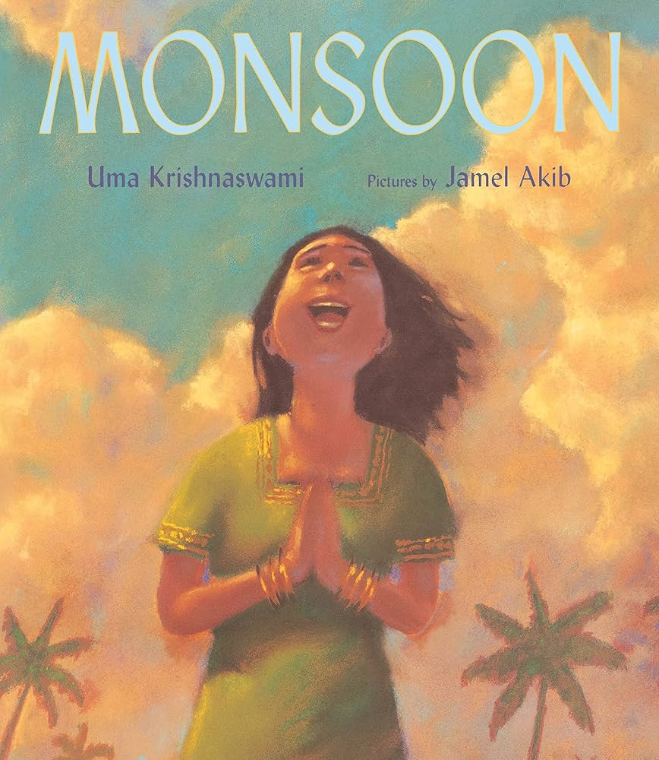 |  | Non-Chronological Report - Ancient Sikh Empire
Year 5  Genre  Progression | Describe setting, characters and atmosphere.  Describe the character and include their feelings using show don’t tell. Use show don’t tell to build suspense. Use short sentences for tension. Cliff hanger questions.  Use dialogue to convey a character and advance the action.  Use organisational and presentational devices that are relevant to the text type, for example, underlining / uppercase. |  |  |  |  |  | Include two adjectives in my fronted adverbial of place.  “Under the ancient, crumbling bridge,”  Using rich description to interest the reader such as metaphors, personification, and onomatopoeia. |  | Independent research.  Select own sub-headings.  Use examples for presentation/structure.  Include a glossary.  Consider audience (fun, factual etc).
Year 6 Genre Progression | Author’s style of writing and use appropriate author’s voice  Consider purpose and audience  Changing tenses – flashback |  |  |  |  |  | Power of three fronted adverbials  Personification of the weather  Evocative language to create a mood, strong feelings, memories, or emotions back  Consider the audience, purpose and write using the appropriate author’s voice |  | Presentation/structure to be independently planned  References sources of data  Independent research  Use a range of presentational devices (table, diagram)  Include questions for intrigue/to entice the reader  Author’s style of writing and use appropriate author’s voice  Consider purpose and audience
Handwriting- Maintain legibility in joined handwriting when writing at speed.
Year 5 Grammar and Punctuation | Use dashes to add parenthesis. |  |  |  |  |  | Use rich description for interest, (metaphors, personification, onomatopoeia)  Use a metaphor as an opener. |  | Use brackets to add parenthesis.
Year 6 Grammar and Punctuation | Consolidation of using dashes to add parenthesis  Integrate dialogue in narratives to convey character and advance the action.  Distinguish between the language of speech and writing and choose the appropriate register. |  |  |  |  |  | Make purposeful choices with adverbs, adjectives, ENPs and adverbials to make writing more descriptive. |  | Use linking adverbials (adverbials of cause) to show reasons or results.
Summer 2
Science Animals (Y6
Geography Own fieldwork study(Kapow Cycle B)
Text and Genre | Retell |  | Write alternative ending or own ending to the story. |  |  |  | Non- Chronological Report
Year 5  Genre Progression | Describe setting, characters and atmosphere.  Describe the character and include their feelings using show don’t tell. Use show don’t tell to build suspense. Use short sentences for tension. Cliff hanger questions.  Use dialogue to convey a character and advance the action.  Use organisational and presentational devices that are relevant to the text type, for example, underlining / uppercase. |  | Describe setting, characters and atmosphere.  Describe the character and include their feelings using show don’t tell. Use show don’t tell to build suspense. Use short sentences for tension. Cliff hanger questions.  Use dialogue to convey a character and advance the action.  Use organisational and presentational devices that are relevant to the text type, for example, underlining / uppercase. |  |  |  | Independent research.  Select own sub-headings.  Use examples for presentation/structure.  Include a glossary.  Consider audience (fun, factual etc).
Year 6 Genre Progression | Author’s style of writing and use appropriate author’s voice  Consider purpose and audience  Changing tenses – flashback |  | Author’s style of writing and use appropriate author’s voice  Consider purpose and audience  Changing tenses – flashback
Handwriting- Maintain legibility in joined handwriting when writing at speed.
Year 5  Grammar and Punctuation | Consolidation of previously taught skills. |  | Consolidation of previously taught skills. |  |  |  | Consolidation of previously taught skills.
Year 6 Grammar and Punctuation | Consolidation of previously taught skills. |  | Consolidation of previously taught skills
These skills may need to taught in isolation:
Add a comma to avoid ambiguity and change the meaning of a single clause sentence with adverbials.
Use a comma before the relative clause if it is providing extra, non-essential information and is after the main clause.
Add a comma to avoid ambiguity and change the meaning of a single clause sentence with adverbials.

