- All new vocabulary will be displayed on Working Walls in the classroom environment.  - WAGOLL to use for whole class teaching demonstrating the skills and vocabulary expectations. |  |  |  |  |  | - Learning is progressive and therefore texts and skills need to be taught in chronological order.  - New ambitious vocabulary will be introduced and pre taught by staff weekly using a range of adjectives, verbs, nouns, adverbs.
Autumn 1
History- Pharaohs
Text and Genre | 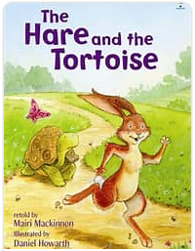  Retell- Hare and Tortoise |  | Retell- Disgusting  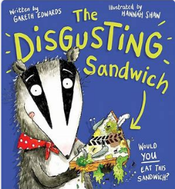 |  | Retell - Storm Whale  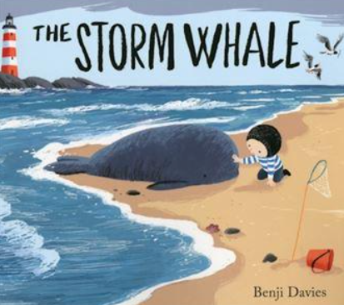 |  |  | Diary - Children write as Noi after discovering the whale on the beach. |  | How to Build a Bug Hotel  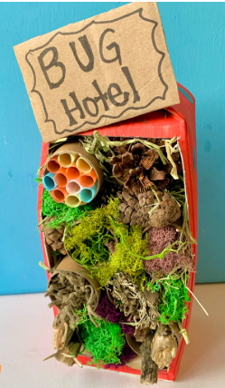 |  | Setting-  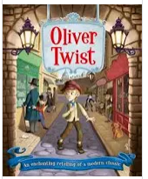
Year 3 Genre Progression | Title to make the reader want to read the story  Using paragraphs to organise my writing |  | Title to make the reader want to read the story  Using paragraphs to organise my writing |  | Title to make the reader want to read the story  Using paragraphs to organise my writing |  |  | Experiment with future tense. Informal voice. Paragraphs for events. Varied language to convey thoughts and feelings. Adverbs as openers. Addresses the diary directly. Includes opinions and facts. Informal, chatty language  Ambitious words to describe people and settings. Talks about secret / private feelings and opinions. Includes events that are important to the writer. |  | Persuasive introduction.  Subheadings – Equipment and method. Openers (time adverbials, imperative verbs, -ly adverbs +subordinating conjunctions).  use a range of openers.  Equipment subheading will be followed by a colon and bullet points. Technical vocabulary / scientific vocabulary. Prepositional phrases Top tips / safety tips / handy hints at the end. |  | What did they see?  Simile as a sentence opener  Show don’t tell to convey a character’s emotion  Beginning to use personification to describe things in my writing
Year 4 Genre Progression | Including build-up, problem, resolution (Story-map)  Independently structuring paragraphs around an idea  Show not tell for character’s emotions  Detailed description of character and setting |  | Including build-up, problem, resolution (Story-map)  Independently structuring paragraphs around an idea  Show not tell for character’s emotions  Detailed description of character and setting  Year 4 limit to one piece of speech |  | Including build-up, problem, resolution (Story-map)  Independently structuring paragraphs around an idea  Show not tell for character’s emotions  Detailed description of character and setting  Year 4 limit to one piece of speech |  |  | Introduction to set the scene and create atmosphere. Events described from the author’s perspective. Talks about feelings, reactions an opinion. Author explains reason for their actions. Ends with the authors present situation, wondering what they will do next. Select events thinking about the audience. Varied language to convey thoughts and feelings and opinions (Show don’t tell). Justify why things happened. Select and maintain the appropriate tense (within given paragraphs)  Use a rhetorical question with a subordinating conjunction |  | Rhetorical question in the introduction  Closing statement  More than one sentence for some steps.  Use adverbs of manner as openers (fronted adverbials) |  | What did they see?  Simile as a sentence opener  Show don’t tell to convey a character’s emotion  Beginning to use personification to describe things in my writing
Handwriting – Use the diagonally and horizontal strokes that are needed to join letters.
Year 3  Grammar and Punctuation | Consoldiation of sentence openers  Use more exciting adjectives and expanded noun phrases to help the reader clearly see what I am describing.  Use a comma to separate adjectives when describing a noun.  Use verb tenses correctly most of the time (was/were) (is/are). (Ongoing). |  | Write compound sentences by including co-ordinating conjunctions (or, and, but, so, yet).  Use a comma before some co-ordinating conjunctions (or, but, so) |  | Use powerful verbs to make my writing more interesting.  Begin to build cohesion by choosing the right nouns and pronouns to avoid repeating myself. |  |  | Begin to extend sentences to add more detail by using a variety of subordinating conjunctions at the start of a sentence to write a complex sentence. Before, After, While, As (+ Year 2)  Use show don’t tell to convey a character’s emotions.  Use tense accurately most of the time. |  | Use a question in a non-fiction introduction.  Use a colon before a list in instructional writing (what you need:)  Consolidation of subordinating conjunctions. (If) |  | Use similes to add description to my writing.  Use prepositions to express place.
Year 4  Grammar and Punctuation | Use a comma after a fronted adverbial.  Use ambitious adjectives to enhance the nouns in the writing. |  | Use the acronym FANBOYS to help me remember coordinating conjunctions  (All of Year 3 + for, nor). |  | Choose the most appropriate verbs to accurately describe to the reader what is being described.  Choose the most appropriate nouns and pronouns. |  |  | Extend sentences to add more detail by using a variety of subordinating conjunctions (All of Year 3 + during, since) at the start and in the middle of a sentence.  Write a complex question sentence to emphasis my point in both fiction and non-fiction writing. |  | Consolidation of subordinating conjunctions. (If) |  | Use more sophisticated similes to describe things in my writing.  Use prepositions as fronted adverbials and include an adjective to give the reader more information.
Autumn 2
Science:
Text and Genre | Character Description- Mr Twit  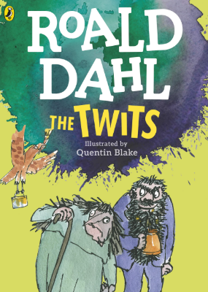 |  | Retell- One trick |  | Formal persuasive letter |  |  | Retell-  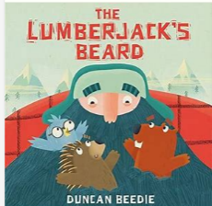 |  | Explanation -State of matter - How Does the Water Cycle Work?  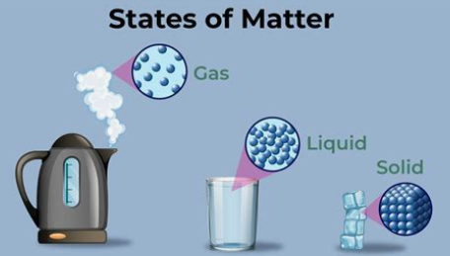 |  |   Retell-Mog’s Christmas Calamity (Sainsbury’s Christmas advert.)
Year 2  Genre Progression | Past tense.  More ambitious vocabulary choices  Range of prepositional phrases as openers  Similes and metaphors |  | Title to make the reader want to read the story  Using paragraphs to organise my writing |  | A letter to request (persuasive letter). Includes address of the recipient. Include more formal sentence. Add more details organised into paragraphs  Begin to use a suitable tone – choose appropriate vocabulary (from a word bank)  Conclusion – saying what needs to happen next. Finish with ‘Yours Faithfully’ / ‘Yours Sincerely’ (descending if you know their name). . Include a question for the recipient to reply to. Include a rhetorical question. Adverbs as openers. Choice of formal ending |  |  | Title to make the reader want to read the story  Using paragraphs to organise my writing |  | Use how or why in the title  Persuasive question in the introduction  More detailed introduction  Closing statement  Facts given by the teacher  Very directed research  Given subheadings  Conjunctions for cause  because / as / so /since |  | Title to make the reader want to read the story  Using paragraphs to organise my writing
Year 3  Genre Progression | Past tense.  More ambitious vocabulary choices  Range of prepositional phrases as openers  Similes and metaphors  Include speech to show personality |  | Including build-up, problem, resolution (Story-map)  Independently structuring paragraphs around an idea  Show not tell for character’s emotions  Detailed description of character and setting  Year 4 limit to one piece of speech |  | Include sender’s address  Formal/detailed introduction  Justification of thoughts  Persuasive openers  Facts  Rhetorical questions |  |  | Including build-up, problem, resolution (Story-map)  Independently structuring paragraphs around an idea  Show not tell for character’s emotions  Detailed description of character and setting  Year 4 limit to one piece of speech |  | Title to intrigue  Start to choose own subheadings  Subheading as a question  Compare vocabulary  Use a wider variety of conjunctions for cause  Consequently / therefore / as a result  These can be used at the beginning or the middle of a sentence. |  | Including build-up, problem, resolution (Story-map)  Independently structuring paragraphs around an idea  Show not tell for character’s emotions  Detailed description of character and setting  Year 4 limit to one piece of speech
Handwriting - Use the diagonally and horizontal strokes that are needed to join letters.
Year 2  Grammar and Punctuation | Consolidate similes  Consistently use an apostrophe to show possession and use apostrophes in my writing to show singular possession. |  | Use powerful verbs to make my writing more interesting.  Begin to build cohesion by choosing the right nouns and pronouns to avoid repeating myself. |  | Use conjunctions for cause (because, as, so) |  |  | Consolidation of skills (AFL) |  | Consolidation of conjunctions for cause. |  | Use of a comma to list expanded noun phrases.
Year 3  Grammar and Punctuation | Modify a noun phrase with an adjective, noun or preposition.  Include one piece of speech  Possessive apostrophe revision. |  | Choose the most appropriate verbs to accurately describe to the reader what is being described.  Choose the most appropriate nouns and pronouns. |  | Use a wider a range of conjunctions for cause.  Write a complex question sentence to emphasis my point in both fiction and non-fiction writing. (Non-fiction) |  |  | Include direct speech in stories but change where the reporting clause is in the sentence (beginning and end).  Mark the reporting clause (who said it) with a comma when it is not at the end of the sentence. |  | Consolidation of conjunctions for cause. |  | Consolidation - Modify a noun phrase with an adjective, noun or preposition.  Consolidate speech
Spring 1
Science:
Text and Genre | List Poem  (Potion for Winter)  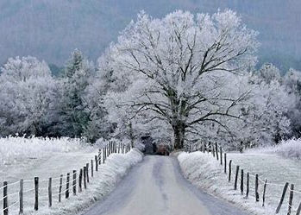 |  | Retell- First half of the story  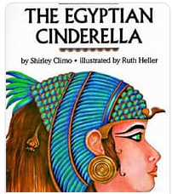 |  | Retell- Next part of the story |  |  | Retell- The time-slipScarab   |  | Non- Chronological Report- mummification  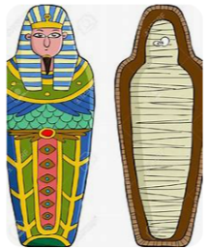
Year 3  Genre Progression | A ‘list poem’ gets its name from the fact that most of the poem is made up of a long list of things. A list poem usually has a few lines at the beginning, a list in the middle and a few lines at the end. |  | Title to make the reader want to read the story  Using paragraphs to organise my writing  Limit speech |  | Title to make the reader want to read the story  Using paragraphs to organise my writing  Limit speech |  |  | Title to make the reader want to read the story  Using paragraphs to organise my writing  Limit speech |  | Teacher led research (content provided by teacher)  Use given sub-headings but arrange information independently  Generate captions for given images  Begin to use the 5w’s in the introduction  Provided reason for processes
Year 4  Genre Progression |  |  | Including build-up, problem, resolution (Story-map)  Independently structuring paragraphs around an idea  Show not tell for character’s emotions  Detailed description of character and setting  Limit speech |  | Including build-up, problem, resolution (Story-map)  Independently structuring paragraphs around an idea  Show not tell for character’s emotions  Detailed description of character and setting  Limit speech |  |  | Including build-up, problem, resolution (Story-map)  Independently structuring paragraphs around an idea  Show not tell for character’s emotions  Detailed description of character and setting  Limit speech |  | Select from a choice of sub-headings  Include multiple paragraphs for each sub-heading  Use 5w’s independently  Follow given structure  Technical vocabulary  Factual language  Conjunctions for cause  These can be used at the beginning or the middle of a sentence
Handwriting- Ascenders and descenders do not interfere with writing on the line above and below.
Year 3  Grammar and Punctua | Change the place of the adverb in the sentence. |  | Use inverted commas at the start and end of speech.  Put the reporting clauses at the end of speech.  Use an exclamation mark or a question mark before the closing inverted commas when the reporting clause is at the end of the speech. |  | Use openers (fronted adverbials) as sentence openers: How (Manner), When (Time) and Where (Place).  Use a comma, an exclamation mark or a question mark before the closing inverted commas when the reporting clause is at the end of the speech.  Use ellipses to build suspense. |  |  | Beginning to vary the range of verbs used in the reporting clause to avoid repeating, ‘said’.  Consolidation of FANBOYS  (and, or, so, but) |  | Organise similar ideas into paragraphs in non-fiction writing.  Use a subheading to guide the reader.  Appropriate non-fiction openers  Consolidation of cause-and-effect conjunctions.
Year 4  Grammar and Punctuation | Use a simile as a sentence opener. |  | Consolidation of speech |  | Consolidation of speech  Adverbs to show how (manner) root word spelling change |  |  | Consolidation of FANBOYS |  | Appropriate non-fiction openers  Choose the most appropriate nouns.  Consolidation of cause-and-effect conjunctions.
Spring 2
Text and Genre | Character Description  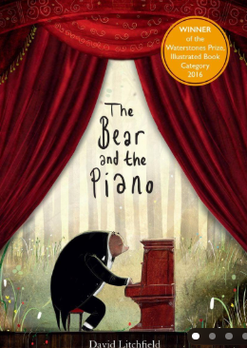 |  | Retell- |  | Postcard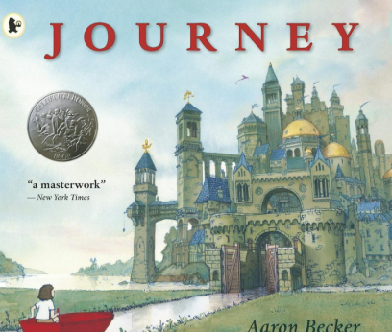  Dear Mum and Dad,  I can't believe where my red crayon has taken me! I have travelled through a magical forest, sailed across a sparkling river and even met a kind purple bird. Everywhere I look, there are towering castles, winding paths and mysterious bridges. My favourite part was gliding through the sky in a hot air balloon because I could see the whole kingdom below me.  Although I miss home, I can't wait to discover what adventure is waiting around the next corner. I wish you could see this amazing place with me!  See you soon.  Love from,  Your adventurous explorer |  |  | Retell  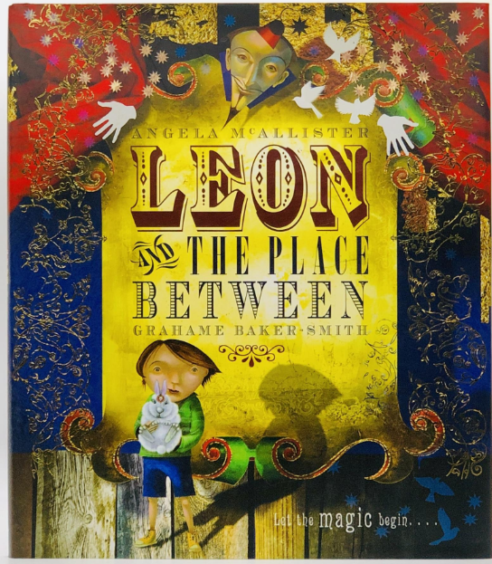 |  | Non- Chronological  Settlements  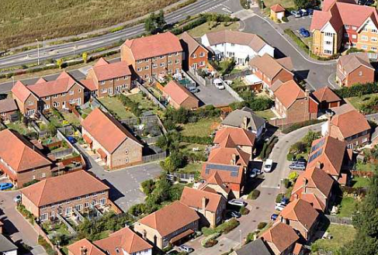
Year 3  Genre Progression | Past tense.  More ambitious vocabulary choices  Range of prepositional phrases as openers  Similes and metaphors |  | Title to make the reader want to read the story  Using paragraphs to organise my writing  Limit speech |  | Include the sender’s address  Use an appropriate greeting  Past tense, include future  tense in the conclusion  Present perfect tense. Write an introduction. Accurate use of tenses (explore future tense)  Paragraphs for time / order  Informal chatty language  Questions sentences. Wider range of contractions. Greeting and signing off (own choice). Consider the audience |  |  | Title to make the reader want to read the story  Using paragraphs to organise my writing  Limit speech |  | Teacher led research (content provided by teacher)  Use given sub-headings but arrange information independently  Generate captions for given images  Begin to use the 5w’s in the introduction  Provided reason for processes
Year 4  Genre Progression | Past tense.  More ambitious vocabulary choices  Range of prepositional phrases as openers  Similes and metaphors  Include speech to show personality |  | Including build-up, problem, resolution (Story-map)  Independently structuring paragraphs around an idea  Show not tell for character’s emotions  Detailed description of character and setting  Limit speech |  | Paragraphs around a theme  Address the reader directly  Present perfect tense  Thoughts and feelings  Show don’t tell  Rhetorical questions |  |  | Including build-up, problem, resolution (Story-map)  Independently structuring paragraphs around an idea  Show not tell for character’s emotions  Detailed description of character and setting  Limit speech |  | Select from a choice of sub-headings  Include multiple paragraphs for each sub-heading  Use 5w’s independently  Follow given structure  Technical vocabulary  Factual language  Conjunctions for cause  These can be used at the beginning or the middle of a sentence
Handwriting- Ascenders and descenders do not interfere with writing on the line above and below.
Year 3  Grammar and | Consolidate similes, powerful verbs and ENPs |  | Use short sentences to make key points. |  | Use the Present Perfect Tense. |  |  | Start a new paragraph to show a change in time in narrative writing. |  | Use a variety of subordinating conjunctions in the middle of a sentence to write a complex sentence.
Year 4  Grammar and Punctuation | Understand the difference between the use of conjunctions, adverbs and prepositions and can explain this. |  | Short sentences to move events on quickly in a story |  | I can explain how to use Present Perfect Tense and use irregular verbs. |  |  | Start a new paragraph when the setting, action or time change in narrative writing. |  | Choose the most appropriate nouns.  Write a complex question sentence to emphasis my point in both fiction and non-fiction writing.
Summer 1
Text and Genre | 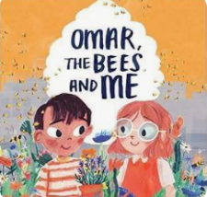  Retell -first half | Retell- 2nd half |  | 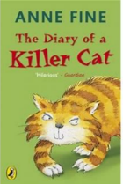  Dad’s Diary Entry- Despising the cat! |  |  | Retell a chapter  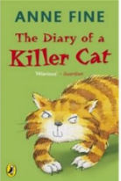  (Dad putting the dead bunny back.) |  | 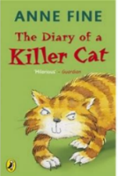  Diary Entry- Tuffy (Could be the day he goes to the vet’s) |  | Free Verse Poetry on cats  
Year 3  Genre  Progression | Title to make the reader want to read the story  Using paragraphs to organise my writing  Include simple speech with inverted commas. Limited speech  Detailed description of character or setting | Title to make the reader want to read the story  Using paragraphs to organise my writing  Include simple speech with inverted commas. Limited speech  Detailed description of character or setting |  | Past perfect and present progressive tenses. Experiment with future tense. Informal voice. Paragraphs for events. Varied language to convey thoughts and feelings. Adverbs as openers. Addresses the diary directly. Includes opinions and facts  Informal, chatty language  Ambitious words to describe people and settings. Talks about secret / private feelings and opinions  Includes events that are important to the writer. Use paragraphs to organise events |  |  | Title to make the reader want to read the story  Using paragraphs to organise my writing  Include simple speech with inverted commas. Limited speech  Detailed description of character or setting |  | Past perfect and present progressive tenses. Experiment with future tense. Informal voice. Paragraphs for events. Varied language to convey thoughts and feelings. Adverbs as openers. Addresses the diary directly. Includes opinions and facts  Informal, chatty language  Ambitious words to describe people and settings. Talks about secret / private feelings and opinions  Includes events that are important to the writer. Use paragraphs to organise events |  | Free Verse poems tell a story, describe something or explain an emotion.  These poems do not need to rhyme or use a structure.  Figurative language.  language linked to the topic.  Capital letters at the beginning of each line.  Free verse poems do not have a certain number of syllables per line.  They do not rhyme, and other language devices may be used.  Lines can be single words, phrases, or sentences.  Own vocabulary choices.
Year 4  Genre  Progression | Including build-up, problem, resolution (Story-map)  Independently structuring paragraphs around an idea  Show not tell for character’s emotions  Detailed description of character and setting  Direct speech to move the action on  3 part speech – what they said, who said it and how they said it (adverb)  Still limit speech | Including build-up, problem, resolution (Story-map)  Independently structuring paragraphs around an idea  Show not tell for character’s emotions  Detailed description of character and setting  Direct speech to move the action on  3 part speech – what they said, who said it and how they said it (adverb)  Still limit speech |  | Introduction to set the scene and create atmosphere. Events described from the author’s perspective. Talks about feelings, reactions an opinion. Author explains reason for their actions. Ends with the authors present situation, wondering what they will do next. Select events thinking about the audience. Varied language to convey thoughts and feelings and opinions (Show don’t tell). Justify why things happened. Select and maintain the appropriate tense (within given paragraphs)  Use a rhetorical question with a subordinating conjunction |  |  | Including build-up, problem, resolution (Story-map)  Independently structuring paragraphs around an idea  Show not tell for character’s emotions  Detailed description of character and setting  Direct speech to move the action on  3 part speech – what they said, who said it and how they said it (adverb)  Still limit speech |  | Introduction to set the scene and create atmosphere. Events described from the author’s perspective. Talks about feelings, reactions an opinion. Author explains reason for their actions. Ends with the authors present situation, wondering what they will do next. Select events thinking about the audience. Varied language to convey thoughts and feelings and opinions (Show don’t tell). Justify why things happened. Select and maintain the appropriate tense (within given paragraphs)  Use a rhetorical question with a subordinating conjunction
Handwriting- My handwriting style is consistent throughout my work.
Year 3 Grammar and Punctuation | Begin to use a comma after a fronted adverbial. | Use adverbs to show when something happened (Time)  Consolidate speech. |  | Use the Present Perfect Tense. |  |  | Start a new paragraph when the setting changes in narrative writing. |  | Use conjunctions to show when something happened. (time - After, Before, While)) |  | Use two –ly adverbs in a sentence.
Year 4 Grammar and Punctuation | Revision of fronted adverbials. | Consolidation of speech. |  | Revision of present perfect. |  |  | Use a mixture of short sentences, simple sentences, compound and complex sentences. |  | Include complex sentences in my writing which start with a subordinating conjunction and marking the subordinating clause with a comma. |  | Beginning to use personification to describe things in my writing.
Summer 2
Text and Genre | Retell-And Tango Makes Three  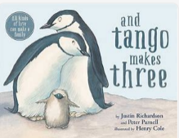 | Retell- The Man Who Walked Between the Towers  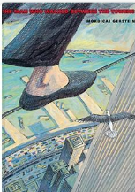 |  | Biography- Lenny Henry  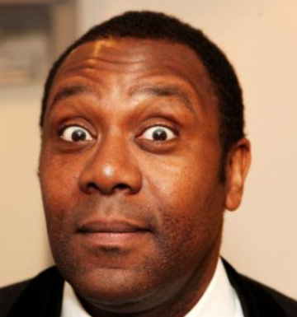 |  |  |  |  | Persuasive Tourist Information Leaflet- visit Black Rock  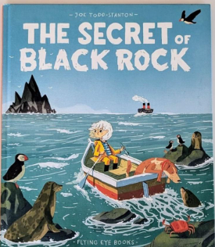
Year 3  Genre Progression | Title to make the reader want to read the story  Using paragraphs to organise my writing  Limit speech | Title to make the reader want to read the story  Using paragraphs to organise my writing  Limit speech |  | In the past tense  Third person  Opening sentence to summarise life  Facts and accomplishments about the person  Details about family |  |  |  |  | Teacher led research (content provided by teacher)  Use given sub-headings but arrange information independently  Generate captions for given images  Begin to use the 5w’s in the introduction  Exaggerate positive points
Year 4  Genre Progression | Including build-up, problem, resolution (Story-map)  Independently structuring paragraphs around an idea  Show not tell for character’s emotions  Detailed description of character and setting  Limit speech | Including build-up, problem, resolution (Story-map)  Independently structuring paragraphs around an idea  Show not tell for character’s emotions  Detailed description of character and setting  Limit speech |  | Includes feeling about times and occasions in their life. |  |  |  |  | Select from a choice of sub-headings  Include multiple paragraphs for each sub-heading  Use 5w’s independently  Follow given structure  Technical vocabulary  Factual language  Conjunctions for cause  These can be used at the beginning or the middle of a sentence  Exaggerate positive points
Handwriting- My handwriting style is consistent throughout my work.
Year 3  Grammar and punctuation | Consolidation of fronted adverbials. | Consolidation of previously taught skills. |  | Use conjunctions to show when something happened. (time - After, Before, While)  Use of the appropriate openers. |  |  |  |  | Consolidation of previously taught skills.
Year 4  Grammar and Punctuation | Use fronted adverbials followed by a comma. When (Frequency) and How (Degree). | Consolidation of previously taught skills. |  | Use of the appropriate openers. |  |  |  |  | Consolidation of previously taught skills.

The following skills might need to be taught in isolation at some point.
Use prepositions to express time.
Use adverbs to show where something happened. (Place)
Use conjunctions for place (Where and Wherever).
Add an ‘s’ to show plural and use irregular plural noun forms of plural (children, women)
Add an ‘s’ to show plural and use irregular plural noun forms of plural. -es words (foxes, boxes).
Understand the difference between the use of conjunctions, adverbs and prepositions and can explain this.

