- All new vocabulary will be displayed on Working Walls in the classroom environment.  - WAGOLL to use for whole class teaching demonstrating the skills and vocabulary expectations. |  |  |  |  |  | - Learning is progressive and therefore texts and skills need to be taught in chronological order.  - New ambitious vocabulary will be introduced and pre taught by staff weekly using a range of adjectives, verbs, nouns, adverbs.
Autumn 1
SCIENCE: Animals HISTORY: What is History? (holidays)
Text and Genre | 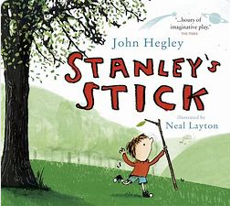 |  | Retell- Alfie on Holiday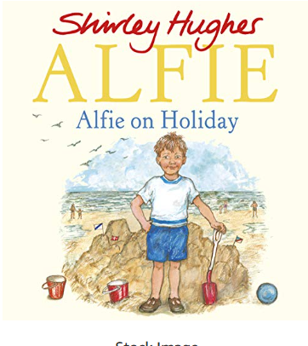 |  | Retell- Handas Surprise  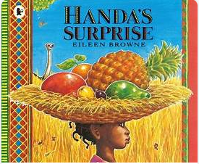 |  |  | Retell- Too Much Stiff  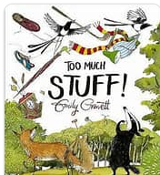 |  | 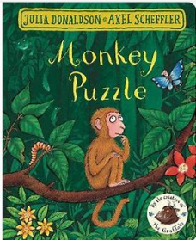  Retell- Monkey Puzzle |  | Recount- Jane Goodall  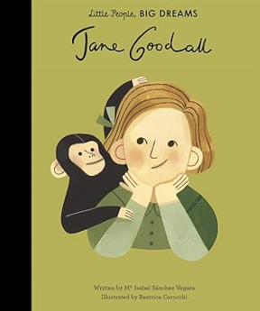
Year 1 Genre Features | Handwriting |  | Handwriting |  | Handwriting |  |  | Use past tense  Include beginning, middle end  Chronological order  Time words  Simple sentences  Structure needs to be correct  (Not to rewrite word for word / use said.) |  | Use past tense  Include beginning, middle end  Chronological order  Time words  Simple sentences  Structure needs to be correct  (Not to rewrite word for word / use said.) |  | Use time words. Chronological.  Use information based on a real event/experience.
Year 2 Genre Features | Handwriting |  | Use pictures as prompts  Description of the character and setting  No comma would be used after the fronted adverbial opener until Year 3. |  | Use pictures as prompts  Description of the character and setting  No comma would be used after the fronted adverbial opener until Year 3. |  |  | Use pictures as prompts  Description of the character and setting  No comma would be used after the fronted adverbial opener until Year 3. |  | Use pictures as prompts  Description of the character and setting  No comma would be used after the fronted adverbial opener until Year 3. |  | Chronological events  Use proper nouns  Details to interest the reader
Year 1  Grammar and Punctuation | Sit at a table properly and hold my pencil correctly.  I form lower case letters correctly, starting and finishing in the right place.  All letters sit on the line.  Tall letters (ascenders) touch the line above.  Use short letters.  a, c, o, d, g, q, |  | Sit at a table properly and hold my pencil correctly.  I form lower case letters correctly, starting and finishing in the right place.  All letters sit on the line.  Tall letters (ascenders) touch the line above.  Use short letters.  I, t,b,p,k,h,I,j,m,n,r,u,y |  | Sit at a table properly and hold my pencil correctly.  Tall letters (ascenders) touch the line above.  Use short letters.  v,w,z,x |  |  | Think, say and remember a sentence that starts with a time adverbial.  (First, Next, Finally).  Write a sentence starting with a time adverbial and ending with a full stop (fiction)  Write in the past tense. |  | Think, say and remember a sentence that starts with a time adverbial.  (First, Next, Then, After that, Finally). |  | Use the openers ‘ She’ and ‘The’.  Use a capital letter for names of people.
Year 2  Grammar and Punctuation | My letters are close together when I write a word (snuggle my letters).  I fill the line with my writing.  Lower case letters are the same height. |  | Use a wider range of time adverbs at the start of my sentences.  Eg. Later that cold day, A few minutes later.  Use the past tense correctly. |  | Use a wider range of openers at the start of my sentences.  Eg. Everyone, Far away… |  |  | Use a wider range of question openers and end with a question mark.  Eg. Where, Who |  | Use a wider range of exciting openers and use an exclamation mark at the end of an exciting sentence.  Eg. Unexpectedly, |  | Use an expanded noun phrase (noun phrase) using one or more adjectives.
Handwriting Year 1 - Use finger spaces between words.
Handwriting Year 2 - Lower case letters are the same height. Leave equal spaces between words.

Autumn 2
GEOGRAPHY: Where am I? (UK) SEASONAL
Text and Genre | Retell- Coming to England  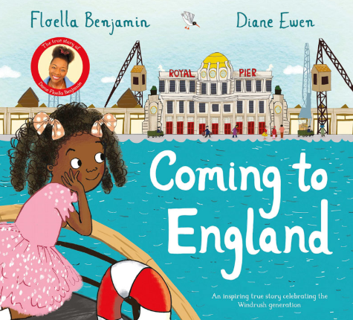 |  | Retell – Island Stories (tvc)  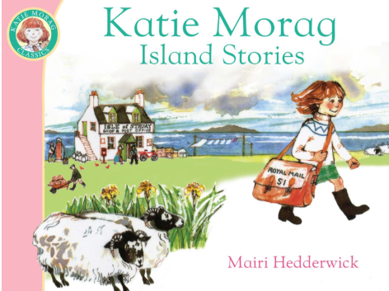 |  | 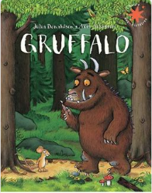  Character Description- The Gruffalo |  |  | Retell- Owl Babies  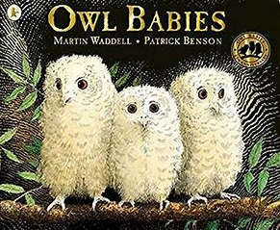 |  | 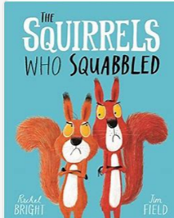  Retell- The Squirrels that Squabbled |  | Instructions – How to make a Melting Snowman Biscuit? / Tree Decorationtbc  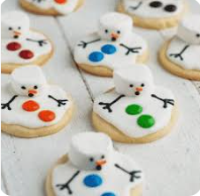
Year 1 Genre Progression | Use past tense  Include beginning, middle end  Chronological order  Time words  Simple sentences  Structure needs to be correct  (Not to rewrite word for word / use said.) |  | Use past tense  Include beginning, middle end  Chronological order  Time words  Simple sentences  Structure needs to be correct  (Not to rewrite word for word / use said.) |  | Wanted poster  Picture annotated  Name of character  What they look like  Simple adjectives (colour and size)  Appearance and personality (appropriate words)  Actions – what does your character do in the story?  Present tense |  |  | Use past tense  Include beginning, middle end  Chronological order  Time words  Simple sentences  Structure needs to be correct  (Not to rewrite word for word / use said.) |  | Use past tense  Include beginning, middle end  Chronological order  Time words  Simple sentences  Structure needs to be correct  (Not to rewrite word for word / use said.) |  | Title  Numbered steps  Each step on a new line  Time adverbial as an opener  Linked to personal experience  Present tense  Linked to oral instructions when playing
Year 2 Genre Progression | Use pictures as prompts  Description of the character and setting  No comma would be used after the fronted adverbial opener until Year 3. |  | Use pictures as prompts  Description of the character and setting  No comma would be used after the fronted adverbial opener until Year 3. |  | Present tense  Separate character description  Describe how the character looks using adjectives and simple similes  Use because / when to describe their personality and actions  Use an ! in an exciting sentence  Include how other characters feel about the character I am describing  Say what I like / dislike about the character. Identify where – using prepositions Select effective vocabulary and up level. Begin to experiment with word order in sentence structure, -ly adverbs to describe how an action was performed |  |  | Use pictures as prompts  Description of the character and setting  No comma would be used after the fronted adverbial opener until Year 3. |  | Use pictures as prompts  Description of the character and setting  No comma would be used after the fronted adverbial opener until Year 3. |  | Title with question  What you need  Introduction with a question  Command sentence / Imperative verbs as openers  -ly adverb at the start of the sentence  Top tip / warning  Link to fictional writing
Year 1  Grammar and Punctuation | Write a sentence starting with the ‘He’ and ‘It ’stop.  AFL * |  | Think, say and remember a sentence that starts with a time adverbial or an opener.  Time adverbial / opener always starts with a capital letter.  AFL * |  | AFL *  Use the conjunction ‘and’ to join two words. (The tree was tall and green).  Use adjectives to describe a noun (size and colour).  Decide on tense and stick to it! |  |  | Write a sentence starting with the ‘They’ opener  AFL * |  | Use the conjunction ‘and’ to join two words. (The tree was tall and green). |  | Write in the present tense (instructions).  Write a sentence starting with a time adverbial and ending with a full stop (non-fiction)  AFL *
Year 1  Grammar and Punctuation | *“Dictation gives children opportunities to practise and apply their spelling knowledge and segmenting skills, without having to compose sentences by themselves. It requires them to distinguish between the sounds they hear in order to choose the correct graphemes to represent the sounds and to form the letters correctly.” Research and Review, May 2023
Year 2  Grammar and Punctuation | Use the conjunction ‘because’, ‘in fiction writing.  AFL * |  | Use the conjunctions ‘because’, ‘and’ in fiction writing.  AFL * |  | Use commas in a list (to list adjectives in a sentence).  Use the conjunctions ‘because’, ‘that’ and ‘and’ in fiction writing.  AFL * |  |  | Consolidate skills wriitng a character description  AFL *  Use the conjunction, ‘that’ in fiction writing.  AFL * |  | Use the conjunction ‘but’. |  | Recognise and write a command sentence with a imperative (bossy) verb and punctuate it with an exclamation mark or a full stop.  Use the present tense correctly.  Use commas in a list (to list nouns in a sentence).  Use ‘because’ and ‘and’ in non-fiction writing.  AFL *
Year 2  Grammar and Punctuation | *“Dictation gives children opportunities to practise and apply their spelling knowledge and segmenting skills, without having to compose sentences by themselves. It requires them to distinguish between the sounds they hear in order to choose the correct graphemes to represent the sounds and to form the letters correctly.” Research and Review, May 2023
Handwriting Year 1 - Form uppercase letters correctly, starting and finishing in the right place.
Handwriting Year 2 - Start using some of the diagonal strokes to join letters.

Spring 1
HISTORY: How have schools changed? SCIENCE: Materials
Text and Genre | Retell- The Great Paper Caper  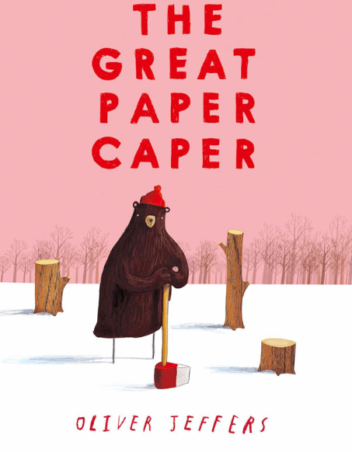 | Diary- Entry  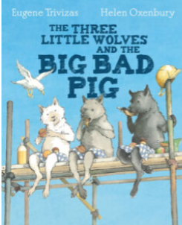 |  | Diary- How to hide a lion at school  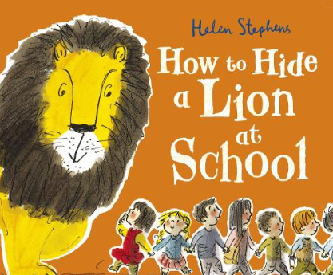 |  |  | Retell- The jolly witch  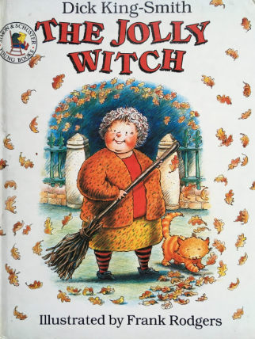 |  | Non- Chronological Report- Seasons  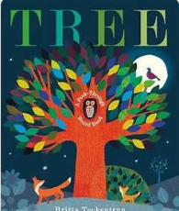 |  | List Poem- Sound Colledctor– Roger Mcough, Sounds in school  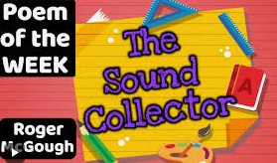
Year 1 Genre Progression | Use past tense  Include beginning, middle end  Chronological order  Time words  Simple sentences  Structure needs to be correct  (Not to rewrite word for word / use said.) | Simple recount of a day  First person  Past tense  Dear Diary |  | Simple recount of a day  First person  Past tense  Dear Diary |  |  | Use past tense  Include beginning, middle end  Chronological order  Time words  Simple sentences  Structure needs to be correct  (Not to rewrite word for word / use said.) |  | Facts gathered as a class  Topic related vocabulary  Given title  Labelled pictures  Present tense |  | A ‘list poem’ gets its name from the fact that most of the poem is made up of a long list of things. A list poem usually has a few lines at the beginning, a list in the middle and a few lines at the end.
Year 2 Genre Progression | Use pictures as prompts  Description of the character and setting  No comma would be used after the fronted adverbial opener until Year 3. | Dear Diary and date  Add in private / secret thoughts and feelings  First person (I, We, My)  Openers –  Past tense  Use time adverbials to show when things happened  Chronological order  Simple conclusion looks ahead to the future (future tense using the conjunction ‘If’) and includes a rhetorical question  Informal language (contractions) |  | Dear Diary and date  Add in private / secret thoughts and feelings  First person (I, We, My)  Openers –  Past tense  Use time adverbials to show when things happened  Chronological order  Simple conclusion looks ahead to the future (future tense using the conjunction ‘If’) and includes a rhetorical question  Informal language (contractions) |  |  | Use pictures as prompts  Description of the character and setting  No comma would be used after the fronted adverbial opener until Year 3. |  | Title  Introduction  Include question  Subheadings (given)  Paragraphs (from given structure)  Ending/closing sentence  Scientific/technical language
Year 1  Grammar and Punctuation | Include an exclamation mark to demarcate exciting sentences. | Use the personal pronoun ‘I’ (when writing a personal recount).  To write in the first person, I, My).  AFL * |  | Use adjectives to describe thoughts and feelings (diary entry).  AFL * |  |  | Use a question mark to demarcate a question sentence starting with Will and What.  AFL * |  | Consolidate all skills in a non-fiction piece of writing.  AFL *  Use non-fiction openers- Lots, Many, Some. |  | AFL *  -ing suffix
Year 1  Grammar and Punctuation | *“Dictation gives children opportunities to practise and apply their spelling knowledge and segmenting skills, without having to compose sentences by themselves. It requires them to distinguish between the sounds they hear in order to choose the correct graphemes to represent the sounds and to form the letters correctly.” Research and Review, May 2023
Year 2  Grammar and Punctuation | Recognise and write an exclamative sentence using What or How.  AFL * | Use ‘when’ as an opener/at the start of a sentence. |  | to use an apostrophe to show contractions |  |  | Consolidate all skills in a retell  AFL * |  | Use the conjunctions ‘because’, ‘that’ and ‘and’ in non-fiction writing.  AFL * |  | AFL *
Year 2  Grammar and Punctuation | *“Dictation gives children opportunities to practise and apply their spelling knowledge and segmenting skills, without having to compose sentences by themselves. It requires them to distinguish between the sounds they hear in order to choose the correct graphemes to represent the sounds and to form the letters correctly.” Research and Review, May 2023
Handwriting Year 1 -My letters are close together when I write a word (snuggle my letters).
Handwriting Year 2 - Start using some of the horizontal strokes to join letters.

Spring 2
SCIENCE –food and exercise GEOGRAPHY – hot or cold? DT - Windmills
Text and Genre | Recount of Hook Day (Make an Exercise Video?)   | Character Description- The Great Explorer – Polar Bear  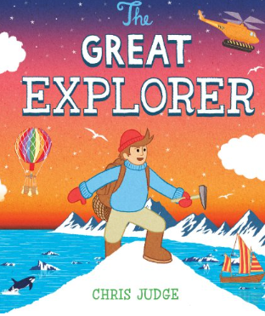 |  | Retell – Great Explorer |  |  | Diary Entry – The Disgusting Sandwich  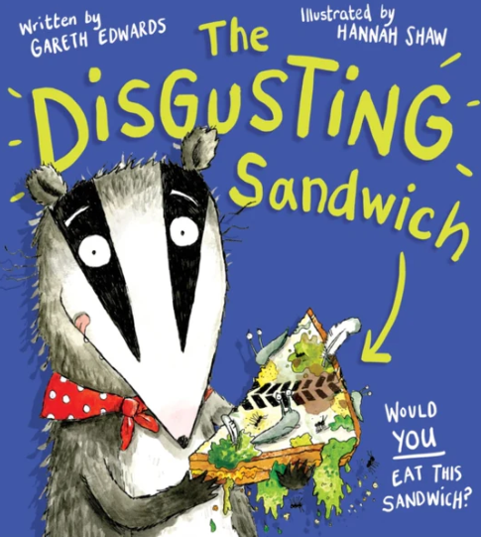 |  | Riddles- food   |  | Riddles-Animals  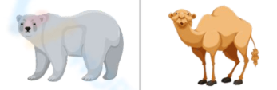
Year 1 Genre Progression | Use first person.  Use time words. Chronological.  Use information based on a real event/experience. | Wanted poster  Picture annotated  Name of character  What they look like  Simple adjectives (colour and size)  Appearance and personality (appropriate words)  Actions – what does your character do in the story?  Present tense |  | Use past tense  Include beginning, middle end  Chronological order  Time words  Simple sentences  Structure needs to be correct  (Not to rewrite word for word / use said.) |  |  | Simple recount of a day  First person  Past tense  Dear Diary |  | Riddle  What am I?  Openers  New clue, new line.  Present tense.  Conjunctions – and  Tease the reader.  Adjectives |  | Riddle  What am I?  Openers  New clue, new line.  Present tense.  Conjunctions – and  Tease the reader.  Adjectives
Year 2 Genre Progression | Chronological events  5w’s to introduce  Use proper nouns  Emotions to describe feelings (I was excited when….)  Final statement (My favourite part was…)  Details to interest the reader  Exclamative sentence to close | Present tense  Separate character description  Describe how the character looks using adjectives and simple similes  Use because / when to describe their personality and actions  Use an ! in an exciting sentence  Include how other characters feel about the character I am describing  Say what I like / dislike about the character. Identify where – using prepositions Select effective vocabulary and up level. Begin to experiment with word order in sentence structure, -ly adverbs to describe how an action was performed |  | Use pictures as prompts  Description of the character and setting  No comma would be used after the fronted adverbial opener until Year 3. |  |  | Dear Diary and date  Add in private / secret thoughts and feelings  First person (I, We, My)  Openers –  Past tense  Use time adverbials to show when things happened  Chronological order  Simple conclusion looks ahead to the future (future tense using the conjunction ‘If’) and includes a rhetorical question  Informal language (contractions) |  | Riddle  What am I?  Openers  New clue, new line.  Present tense.  , but  Conjunctions – and, that, When, If, or, because.  Tease the reader.  Commas in a list.  Adjectives |  | Riddle  What am I?  Openers  New clue, new line.  Present tense.  , but  Conjunctions – and, that, When, If, or, because.  Tease the reader.  Commas in a list.  Adjectives
Year 1  Grammar and Punctuation | Use a wider variety of time openers (at last, soon, later) | Use a wider variety of openers- On, Her, His. |  | Consolidation of previously taught skills. |  |  | Use ‘and’ to join words and to join clauses in sentences. |  | Use new sentence openers - I have, I am, You (riddles). |  | Use the conjunction ‘and’ when writing a riddle.
Year 1  Grammar and Punctuation | *“Dictation gives children opportunities to practise and apply their spelling knowledge and segmenting skills, without having to compose sentences by themselves. It requires them to distinguish between the sounds they hear in order to choose the correct graphemes to represent the sounds and to form the letters correctly.” Research and Review, May 2023
Year 2  Grammar and Punctuation | Wider range of openers  E.g., In the hall,  Use an -ly adverb as an opener  Slowly, Nervously | Use an apostrophe to show  singular possession.  AFL * |  | Adding the suffix -ful (careful, fearful, powerful, dreadful, wonderful, playful, beautiful).  AFL * |  |  | Introduce the conjunctions ‘if’ and ‘or’.  (Use within a question.) |  | onsolidation of the conjunction ‘if’  Use a wider variety of sentence openers.  E.g., Often, Sometimes, Usaully…C |  | Use the conjucntions  ‘if’, ‘and’, ‘but’, ‘When’, ‘that’, ‘or’, ‘because’ in a riddle.  (Doesn’t need to be all in one riddle.)
Year 2  Grammar and Punctuation | *“Dictation gives children opportunities to practise and apply their spelling knowledge and segmenting skills, without having to compose sentences by themselves. It requires them to distinguish between the sounds they hear in order to choose the correct graphemes to represent the sounds and to form the letters correctly.” Research and Review, May 2023
Handwriting Year 1 - I fill the line with my writing.
Handwriting Year 2 - Start using some of the horizontal strokes to join letters.

Summer 1
HISTORY: What is a Monarch? (Charles 3rd and William Conqueror)
Text and Genre | Retell – The King’s Pants  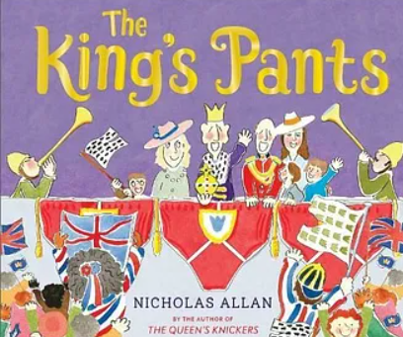 | Retell- Paddington at the Palace  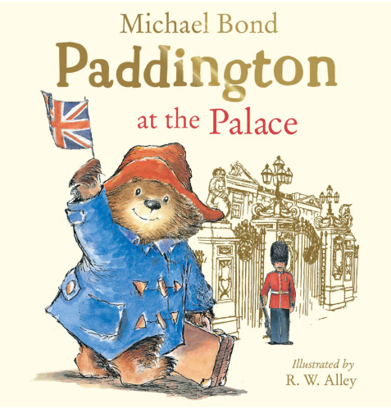 |  | Explanation of a life cycle -Frog  Tad  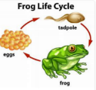  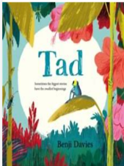 |  |  | Retell- |  | Diary – The Queen’s Hat  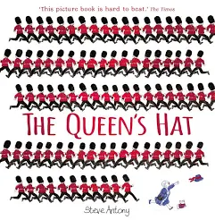 |  | Non- Chronological Report
Year 1 Genre Progression. | Use past tense  Include beginning, middle end  Chronological order  Time words  Simple sentences  Structure needs to be correct  (Not to rewrite word for word / use said.) | Use past tense  Include beginning, middle end  Chronological order  Time words  Simple sentences  Structure needs to be correct  (Not to rewrite word for word / use said.) |  | Present tense.  Time adverbials to sequence the process  It may be helpful if the children write an explanation which is linked to a simple life cycle |  |  | Use past tense  Include beginning, middle end  Chronological order  Time words  Simple sentences  Structure needs to be correct  (Not to rewrite word for word / use said.) |  | Simple recount of a day  First person  Past tense  Dear Diary |  | Facts gathered as a class  Topic related vocabulary  Given title  Labelled pictures  Present tense
Year 2 Genre Progression | Use pictures as prompts  Description of the character and setting  No comma would be used after the fronted adverbial opener until Year 3. | Use pictures as prompts  Description of the character and setting  No comma would be used after the fronted adverbial opener until Year 3. |  | Title  Brief introduction  Scientific language  Subheadings provided by the teacher  Paragraphs  Facts and appropriate order |  |  | Use pictures as prompts  Description of the character and setting  No comma would be used after the fronted adverbial opener until Year 3. |  | Dear Diary and date  Add in private / secret thoughts and feelings  First person (I, We, My)  Openers –  Past tense  Use time adverbials to show when things happened  Chronological order  Simple conclusion looks ahead to the future (future tense using the conjunction ‘If’) and includes a rhetorical question  Informal language (contractions) |  | Title  Introduction  Include question  Subheadings (given)  Paragraphs (from given structure)  Ending/closing sentence  Scientific/technical language
Year 1  Grammar and Punctuation | Focus on using the question words – Where and Who to begin a question sentence.  AFL * | Capital letters for days of the week. |  | Non-fiction openers- Many, Lots, Some |  |  | Use est where no change is needed in the spelling of root words  (smartest quickest) |  | Consolidation of using the personal pronoun ‘I’ |  | Use -er where no change is needed in the spellings of root words.  (taller, brighter, smaller)
Year 1  Grammar and Punctuation | *“Dictation gives children opportunities to practise and apply their spelling knowledge and segmenting skills, without having to compose sentences by themselves. It requires them to distinguish between the sounds they hear in order to choose the correct graphemes to represent the sounds and to form the letters correctly.” Research and Review, May 2023
Year 2  Grammar and Punctuation | To use effective word choices and create a list of adjectives to describe a noun.  Use a comma to separate adjectives when describing a noun. | Add the suffix -ly to change a word from an adjective to an adverb and use as a sentence openers. |  | Use an apostrophe to show singular possession (non-fictional writing) |  |  | AfL |  | Consolidation of using the conjunctions ‘when’ and because. |  | Embed all previous skills.  AFL *
Year 2  Grammar and Punctuation | *“Dictation gives children opportunities to practise and apply their spelling knowledge and segmenting skills, without having to compose sentences by themselves. It requires them to distinguish between the sounds they hear in order to choose the correct graphemes to represent the sounds and to form the letters correctly.” Research and Review, May 2023
Handwriting Year 1 - Fill the line with writing and start a new line when there is not enough space to write the complete word.

Handwriting Year 2 - Start to join handwriting.

Summer 2
SCIENCE: Materials 2 GEOGRAPHY: Shanghai
Text and Genre | Retell- Lighthouse Keepers Lunch  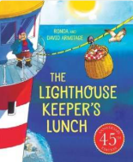 | Instructions- Seagull proof Sandwiches |  | Snail and the whale  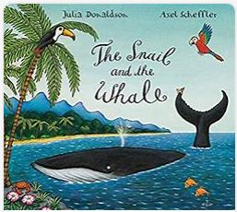  Postcard -Informal Letter |  |  | Retell-  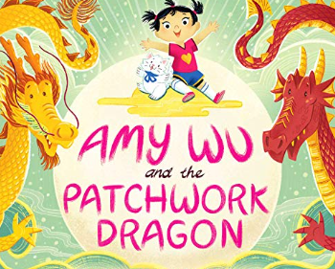 |  | Retell- Lin Yis lantern  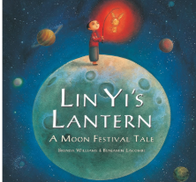 |  | Acrostic Poem- Summer  
Year 1 Genre Progression | Use past tense  Include beginning, middle end  Chronological order  Time words  Simple sentences  Structure needs to be correct  (Not to rewrite word for word / use said.) | Title  Numbered steps  Each step on a new line  What you need with bullet points  Time adverbial as an opener  Linked to personal experience  Present tense  Linked to oral instructions when playing |  | Simple format (To, From)  First person  An informal greeting (Hi)  Add a few sentences  First sentence starts on a new line  From on a new line and add my name  Date |  |  | Use past tense  Include beginning, middle end  Chronological order  Time words  Simple sentences  Structure needs to be correct  (Not to rewrite word for word / use said.) |  | Use past tense  Include beginning, middle end  Chronological order  Time words  Simple sentences  Structure needs to be correct  (Not to rewrite word for word / use said.) |  | An acrostic poem is a poem in which certain letters (usually the first letter of each line)  spells out a word when read vertically. The word is the theme of the poem.
Year 2 Genre Progression | Use pictures as prompts  Description of the character and setting  No comma would be used after the fronted adverbial opener until Year 3. | Title with question  What you need  Introduction with a question  Command sentence / Imperative verbs as openers  -ly adverb at the start of the sentence  Top tip / warning  Link to fictional writing |  | Address and date (Given)  Greeting (From a choice)  Past tense  Detail events  Signing off (given)  Personal thoughts and feelings  Informal (use contractions) |  |  | Use pictures as prompts  Description of the character and setting  No comma would be used after the fronted adverbial opener until Year 3. |  | Use pictures as prompts  Description of the character and setting  No comma would be used after the fronted adverbial opener until Year 3.
Year 1  Grammar and Punctuation | Consolidation of previously taught skills. | Revision of writing in the present tense. |  | Adding the endings –ing, verbs where no change is needed to the root word. |  |  | Embedding all skills.  AFL * |  | Embedding all skills.  AFL * |  | Embedding all skills and layering skills within a sentence.  AFL *
Year 1  Grammar and Punctuation | *“Dictation gives children opportunities to practise and apply their spelling knowledge and segmenting skills, without having to compose sentences by themselves. It requires them to distinguish between the sounds they hear in order to choose the correct graphemes to represent the sounds and to form the letters correctly.” Research and Review, May 2023
Year 2  Grammar and Punctuation | Embedding all skills and layering skills within a sentence.  AFL * | Use a variety of openers.  Time adverbial,  Imperative verbs and adverbs.  Use the conjunction ‘if’ to include a top tip. |  | Write in the progressive present/past tense. |  |  | Embedding all skills.  AFL * |  | Embedding all skills.  AFL * |  | Embedding all skills.  AFL *
Year 2  Grammar and Punctuation | *“Dictation gives children opportunities to practise and apply their spelling knowledge and segmenting skills, without having to compose sentences by themselves. It requires them to distinguish between the sounds they hear in order to choose the correct graphemes to represent the sounds and to form the letters correctly.” Research and Review, May 2023
Handwriting Year 1 - Fill the line with writing and start a new line when there is not enough space to write the complete word.
Handwriting Year 2 - Start to join handwriting.

