- All new vocabulary will be displayed on Working Walls in the classroom environment.  - WAGOLL to use for whole class teaching demonstrating the skills and vocabulary expectations. |  |  |  |  |  |  |  |  | - Learning is progressive and therefore texts and skills need to be taught in chronological order.  - New ambitious vocabulary will be introduced and pre taught by staff weekly using a range of adjectives, verbs, nouns, adverbs.
Autumn 1
History - Stone, Bronze and Iron age |  |  |  |  |  |  |  |  |  | Science – Living Things and Habitats (Y4)
Text and Genre | 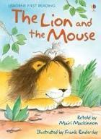  Retell – Lion and the Mouse |  | 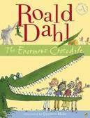  Retell - The Enormous Crocodile (One Trick) |  |  |  | Retell – Stone Age Boy ( One section)  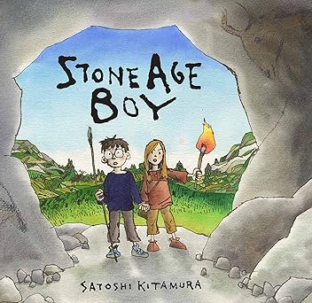 |  |  |  |  | Diary - Dog Day  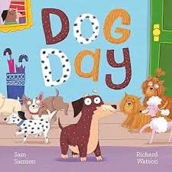 |  |  |  | Retell – The Proudest Blue  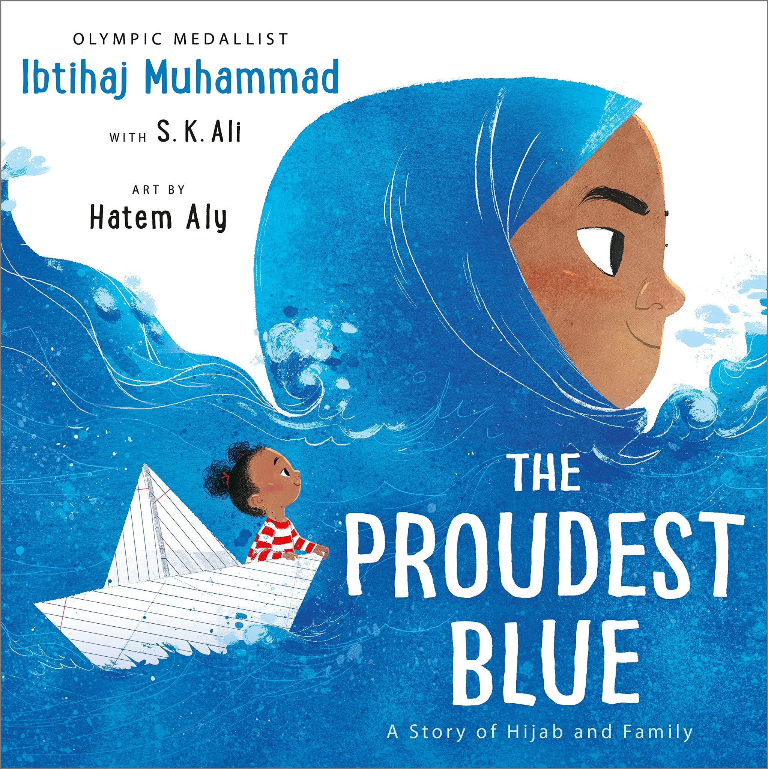 |  | Instructions to make an iron age house
Year 3 Genre Progression | title to make the reader want to read the story  Using paragraphs to organise my writing |  | title to make the reader want to read the story  Using paragraphs to organise my writing |  |  |  | title to make the reader want to read the story  Using paragraphs to organise my writing |  |  |  |  | Experiment with future tense. Informal voice. Paragraphs for events. Varied language to convey thoughts and feelings. Adverbs as openers. Addresses the diary directly. Includes opinions and facts. Informal, chatty language  Ambitious words to describe people and settings. Talks about secret / private feelings and opinions. Includes events that are important to the writer. |  |  |  | title to make the reader want to read the story  Using paragraphs to organise my writing |  | Persuasive introduction.  Subheadings – Equipment and method. Openers (time adverbials, imperative verbs, -ly adverbs +subordinating conjunctions).  use a range of openers.  Equipment subheading will be followed by a colon and bullet points. Technical vocabulary / scientific vocabulary. Prepositional phrases Top tips / safety tips / handy hints at the end.
Year 4 Genre Progression | Including build-up, problem, resolution (Story-map)  Independently structuring paragraphs around an idea  Show not tell for character’s emotions  Detailed description of character and setting |  | Including build-up, problem, resolution (Story-map)  Independently structuring paragraphs around an idea  Show not tell for character’s emotions  Detailed description of character and setting  Year 4 limit to one piece of speech |  |  |  | Including build-up, problem, resolution (Story-map)  Independently structuring paragraphs around an idea  Show not tell for character’s emotions  Detailed description of character and setting  Year 4 limit to one piece of speech |  |  |  |  | Introduction to set the scene and create atmosphere. Events described from the author’s perspective. Talks about feelings, reactions an opinion. Author explains reason for their actions. Ends with the authors present situation, wondering what they will do next. Select events thinking about the audience. Varied language to convey thoughts and feelings and opinions (Show don’t tell). Justify why things happened. Select and maintain the appropriate tense (within given paragraphs)  Use a rhetorical question with a subordinating conjunction |  |  |  | Including build-up, problem, resolution (Story-map)  Independently structuring paragraphs around an idea  Show not tell for character’s emotions  Detailed description of character and setting  Year 4 limit to one piece of speech |  | Rhetorical question in the introduction  Closing statement  More than one sentence for some steps.  Use adverbs of manner as openers (fronted adverbials)
Handwriting – Use the diagonally and horizontal strokes that are needed to join letters.
Year 3  Grammar and Punctuation | Consoldiation of sentence openers  Use more exciting adjectives and expanded noun phrases to help the reader clearly see what I am describing.  Use a comma to separate adjectives when describing a noun.  Use verb tenses correctly most of the time (was/were) (is/are). (Ongoing). |  | Write compound sentences by including co-ordinating conjunctions (or, and, but, so, yet).  Use a comma before some co-ordinating conjunctions (or, but, so) |  |  |  | Use powerful verbs to make my writing more interesting.  Begin to build cohesion by choosing the right nouns and pronouns to avoid repeating myself. |  |  |  |  | Begin to extend sentences to add more detail by using a variety of subordinating conjunctions at the start of a sentence to write a complex sentence. Before, After, While, As (+ Year 2)  Use show don’t tell to convey a character’s emotions.  Use tense accurately most of the time. |  |  |  | Consistently use an apostrophe to show possession and use apostrophes in my writing to show singular possession. |  | Use a question in a non-fiction introduction.  Use a colon before a list in instructional writing (what you need:)  Consoldiation of subordinating conjucntions. (If)
Year 4  Grammar and Punctuation | Use a comma after a fronted adverbial.  Use ambitious adjectives to enhance the nouns in the writing. |  | Use the acronym FANBOYS to help me remember coordinating conjunctions  (All of Year 3 + for, nor). |  |  |  | Choose the most appropriate verbs to accurately describe to the reader what is being described.  Choose the most appropriate nouns and pronouns. |  |  |  |  | Extend sentences to add more detail by using a variety of subordinating conjunctions (All of Year 3 + during, since) at the start and in the middle of a sentence.  Write a complex question sentence to emphasis my point in both fiction and non-fiction writing. |  |  |  | Include direct speech in stories but change where the reporting clause is in the sentence (beginning and end).  Mark the reporting clause (who said it) with a comma when it is not at the end of the sentence. |  | Consoldiation of subordinating conjucntions. (If)
Autumn 2
Science: Forces Y3 |  |  |  |  |  |  |  |  |  | Geography: Volcanoes
Text and Genre | Setting Description - The firework maker's daughter  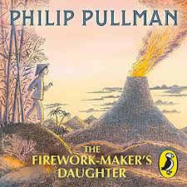 |  | 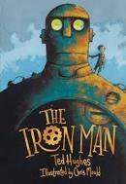  Character Description – The Iron Man |  |  |  | Persuasive Letter – To Stop the Iron Man  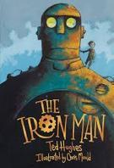 |  |  |  |  | Retell – Robot and the Bluebird  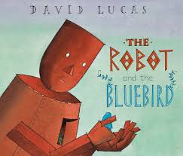 |  |  |  | 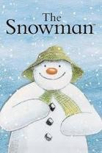  Retell – The Snowman (section) |  | Retell – The Snowman (section)  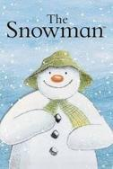
Year 3  Genre Progression | What did they see?  Simile as a sentence opener  Show don’t tell to convey a character’s emotion  Beginning to use personification to describe things in my writing |  | Past tense.  More ambitious vocabulary choices  Range of prepositional phrases as openers  Similes and metaphors |  |  |  | A letter to request (persuasive letter). Includes address of the recipient. Include more formal sentence. Add more details organised into paragraphs  Begin to use a suitable tone – choose appropriate vocabulary (from a word bank)  Conclusion – saying what needs to happen next. Finish with ‘Yours Faithfully’ / ‘Yours Sincerely’ (descending if you know their name). . Include a question for the recipient to reply to. Include a rhetorical question. Adverbs as openers. Choice of formal ending |  |  |  |  | title to make the reader want to read the story  Using paragraphs to organise my writing |  |  |  | title to make the reader want to read the story  Using paragraphs to organise my writing |  | Including build-up, problem, resolution (Story-map)  Independently structuring paragraphs around an idea  Show not tell for character’s emotions  Detailed description of character and setting
Year 4  Genre Progression | What did they see?  Simile as a sentence opener  Show don’t tell to convey a character’s emotion  Beginning to use personification to describe things in my writing |  | Past tense.  More ambitious vocabulary choices  Range of prepositional phrases as openers  Similes and metaphors  Include speech to show personality |  |  |  | Include sender’s address  Formal/detailed introduction  Justification of thoughts  Persuasive openers  Facts  Rhetorical questions |  |  |  |  | Including build-up, problem, resolution (Story-map)  Independently structuring paragraphs around an idea  Show not tell for character’s emotions  Detailed description of character and setting |  |  |  | Including build-up, problem, resolution (Story-map)  Independently structuring paragraphs around an idea  Show not tell for character’s emotions  Detailed description of character and setting |  | Including build-up, problem, resolution (Story-map)  Independently structuring paragraphs around an idea  Show not tell for character’s emotions  Detailed description of character and setting
Handwriting - Use the diagonally and horizontal strokes that are needed to join letters.
Year 3  Grammar and Punctuation | Use similes to add description to my writing.  Use prepositions to express place. |  | Consolidate similes  (Use AFL) |  |  |  | Use conjunctions for cause (because, as, so) |  |  |  |  | Consolidation of skills (AFL) |  |  |  | Use of a comma to list expanded noun phrases. |  | Consolidation of skills (AFL)
Spring 1
History- Romans |  |  |  |  |  |  |  |  |  | Science: Light Y3
Text and Genre |   Free Verse Winter Poetry |  | Retell - The King who banned the dark  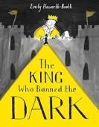 |  |  |  | Retell – The Crow’s Tale  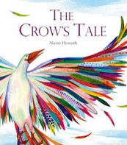 |  |  |  |  | Retell - Oscar and the Moth  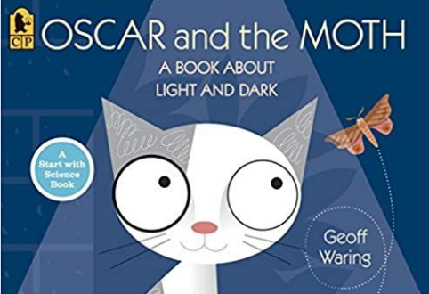 |  |  |  | Diary Entry - Oscar and the Moth |  | Non-chronological report –  Roman Gladiator  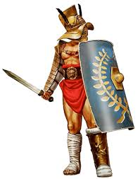
Year 3  Genre Progression | Free Verse poems tell a story, describe something or explain an emotion. These poems do not need to rhyme or use a structure.  language linked to the topic  Capital letters at the beginning of each line. Free verse poems do not have a certain number of  syllables per line. They do not rhyme, and other language devices  may be used. Lines can be single words, phrases or sentences  Own vocabulary choices |  | title to make the reader want to read the story  Using paragraphs to organise my writing |  |  |  | title to make the reader want to read the story  Using paragraphs to organise my writing |  |  |  |  | title to make the reader want to read the story  Using paragraphs to organise my writing |  |  |  | Past perfect and present progressive tenses. Experiment with future tense. Informal voice. Paragraphs for events. Varied language to convey thoughts and feelings. Adverbs as openers. Addresses the diary directly. Includes opinions and facts  Informal, chatty language  Ambitious words to describe people and settings. Talks about secret / private feelings and opinions. Includes events that are important to the writer. Use paragraphs to organise events |  | Teacher led research (content provided by teacher)  Use given sub-headings but arrange information independently  Generate captions for given images  Begin to use the 5w’s in the introduction  Provided reason for processes
Year 4  Genre Progression | Free Verse poems tell a story, describe something or explain an emotion. These poems do not need to rhyme or use a structure.  language linked to the topic  Capital letters at the beginning of each line. Free verse poems do not have a certain number of  syllables per line. They do not rhyme, and other language devices  may be used. Lines can be single words, phrases or sentences  Own vocabulary choices |  | Including build-up, problem, resolution (Story-map)  Independently structuring paragraphs around an idea  Show not tell for character’s emotions  Detailed description of character and setting |  |  |  | Including build-up, problem, resolution (Story-map)  Independently structuring paragraphs around an idea  Show not tell for character’s emotions  Detailed description of character and setting |  |  |  |  | title to make the reader want to read the story  Using paragraphs to organise my writing  Include simple speech with inverted commas. Limited speech  Detailed description of character OR setting |  |  |  | Introduction to set the scene and create atmosphere. Events described from the author’s perspective. Talks about feelings, reactions an opinion. Author explains reason for their actions. Ends with the authors present situation, wondering what they will do next. Select events thinking about the audience. Varied language to convey thoughts and feelings and opinions (Show don’t tell). Justify why things happened. Select and maintain the appropriate tense (within given paragraphs)  Use a rhetorical question with a subordinating conjunction. |  | Select from a choice of sub-headings  Include multiple paragraphs for each sub-heading  Use 5w’s independently  Follow given structure  Technical vocabulary  Factual language  Conjunctions for cause  These can be used at the beginning or the middle of a sentence
Handwriting- Ascenders and descenders do not interfere with writing on the line above and below.
Year 3  Grammar and  Punctuation | Change the place of the adverb in the sentence. |  | Use inverted commas at the start and end of speech.  Put the reporting clauses at the end of speech.  Use an exclamation mark or a question mark before the closing inverted commas when the reporting clause is at the end of the speech. |  |  |  | Use a comma, an exclamation mark or a question mark before the closing inverted commas when the reporting clause is at the end of the speech.  Use ellipses to build suspense. |  |  |  |  | Use openers (fronted adverbials) as sentence openers: How (Manner), When (Time) and Where (Place). |  |  |  | Use a variety of subordinating conjunctions in the middle of a sentence to write a complex sentence. |  | Organise similar ideas into paragraphs in non-fiction writing.  Use a subheading to guide the reader.  Appropriate non-fiction openers
Year 4  Grammar and Punctuation | Adverbs to show how (manner) root word spelling change |  | Consolidation of speech |  |  |  | Consolidation of speech |  |  |  |  | Begin to use a comma after a fronted adverbial. |  |  |  | Include complex sentences in my writing which start with a subordinating conjunction and marking the subordinating clause with a comma. |  | Appropriate non-fiction openers
Spring 2
Science: Rocks Y3 |  |  |  |  |  |  |  |  |  | Geography: Rainforests
Text and Genre | Retell – Ratty’s Big Adventure  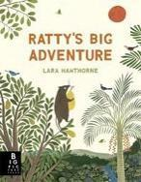 |  | 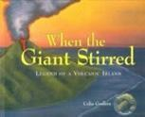  Setting Description – When a Giant Stirred |  |  |  | Retell – The Pebble in my Pocket  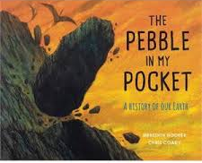 |  |  |  |  | Mole in the Hole - letter to the rocks |  |  |  | Non-chronological report about Rainforests  
Year 3  Genre Progression | title to make the reader want to read the story  Using paragraphs to organise my writing |  | Similes and metaphors  Fronted adverbials for place and manner  Adjective, adjective  Powerful verbs |  |  |  | title to make the reader want to read the story  Using paragraphs to organise my writing  Include simple speech with inverted commas. Limited speech  Detailed description of character OR setting |  |  |  |  | Include the sender’s address  Use an appropriate greeting  Past tense, include future  tense in the conclusion  Present perfect tense. Write an introduction. Accurate use of tenses (explore future tense)  Paragraphs for time / order  Informal chatty language  Questions sentences. Wider range of contractions. Greeting and signing off (own choice). Consider the audience |  |  |  | Teacher led research (content provided by teacher)  Use given sub-headings but arrange information independently  Generate captions for given images  Begin to use the 5w’s in the introduction  Provided reason for processes
Year 4  Genre Progression | Including build-up, problem, resolution (Story-map)  Independently structuring paragraphs around an idea  Show not tell for character’s emotions  Detailed description of character and setting |  | What did they see?  Simile as a sentence opener  Show don’t tell to convey a character’s emotion  Beginning to use personification to describe things in my writing |  |  |  | Including build-up, problem, resolution (Story-map)  Independently structuring paragraphs around an idea  Show not tell for character’s emotions  Detailed description of character and setting |  |  |  |  | Paragraphs around a theme  Address the reader directly  Present perfect tense  Thoughts and feelings  Show don’t tell  Rhetorical questions |  |  |  | Select from a choice of sub-headings  Include multiple paragraphs for each sub-heading  Use 5w’s independently  Follow given structure  Technical vocabulary  Factual language  Conjunctions for cause  These can be used at the beginning or the middle of a sentence
Handwriting- Ascenders and descenders do not interfere with writing on the line above and below.
Year 3  Grammar and | Start a new paragraph to show a change in time in narrative writing. |  | Consolidate similes, powerful, ENP |  |  |  | Use short sentences to make key points.  Beginning to vary the range of verbs used in the reporting clause to avoid repeating, ‘said’. |  |  |  |  | Use the Present Perfect Tense. |  |  |  | Consolidation of skills
Year 4  Grammar and Punctuation | Start a new paragraph when the setting, action or time change in narrative writing. |  | Use more sophisticated metaphors to describe things in my writing.  Beginning to use personification to describe things in my writing. |  |  |  | Short sentences to move events on quickly in a story |  |  |  |  | I can explain how to use Present Perfect Tense and use irregular verbs. |  |  |  | Consolidation of skills
Summer 1 (5 weeks?)
History - Anglo Saxons
Text and Genre | Retell | Character Description of |  |  |  | Retell |  |  |  |  | Right move Advert for an Anglo Saxon house  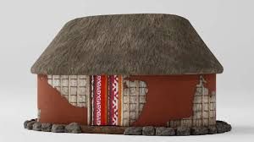 |  |  |  |  |  | Kennings Poetry  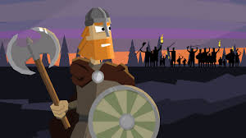
Year 3  Genre  Progression | title to make the reader want to read the story  Using paragraphs to organise my writing  Include simple speech with inverted commas. Limited speech  Detailed description of character OR setting | Past tense.  More ambitious vocabulary choices  Range of prepositional phrases as openers  Similes and metaphors  Include speech to show personality |  |  |  | title to make the reader want to read the story  Using paragraphs to organise my writing  Include simple speech with inverted commas. Limited speech  Detailed description of character OR setting |  |  |  |  | Can take the form of an advert and may not even be written in complete sentences.  Words / phrases might be used to advertise the product.  Present tense. Catchy title and/or slogan. Appeals to the senses  Use alliteration, rhyming words and word play to make it memorable and fun. Exaggerate positive points  Pictures. Powerful verbs and ENPs |  |  |  |  |  | Kenning  A Kennings poem describes what a person, idea  or object is or does  Each line is a simple phrase of a noun + noun or  a noun + verb ( noun + noun: Cheese – eater)
Year 4  Genre  Progression | Including build-up, problem, resolution (Story-map)  Independently structuring paragraphs around an idea  Show not tell for character’s emotions  Detailed description of character and setting  Direct speech to move the action on  3 part speech – what they said, who said it and how they said it (adverb)  Still limit speech | As above |  |  |  | Including build-up, problem, resolution (Story-map)  Independently structuring paragraphs around an idea  Show not tell for character’s emotions  Detailed description of character and setting  Direct speech to move the action on  3 part speech – what they said, who said it and how they said it (adverb)  Still limit speech |  |  |  |  | Can take the form of an advert  Tell a personal story  Give an expert’s opinion  Include statistics |  |  |  |  |  | Kenning  A Kennings poem describes what a person, idea  or object is or does  Each line is a simple phrase of a noun + noun or  a noun + verb ( noun + noun: Cheese – eater)
Handwriting- My handwriting style is consistent throughout my work.
Year 3 Grammar and Punctuation | Use of a comma for rule of three. | Consolidate powerful verbs and similes. |  |  |  | Use different sentence lengths.  Use two –ly adverbs in a sentence. |  |  |  |  | Consolidate conjunctions of cause
Year 4 Grammar and Punctuation | Use fronted adverbials followed by a comma. When (Frequency) and How (Degree). | Consolidate metaphors, similes and powerful verbs. |  |  |  | Use a mixture of short sentences, simple sentences, compound and complex sentences. |  |  |  |  | Consolidate conjunctions of cause.
Summer 2
Science: plants Y3 |  |  |  | Geography: Where does our food come from?
Text and Genre | Biography – ???????? |  |  |  |  | 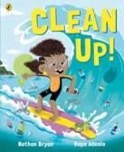  Clean Up – Retell |  |  |  |  | Retell - The Journey Home  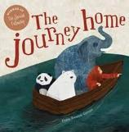 |  |  |  | Non-chronological report – Where does our Food come from?
Year 3  Genre Progression | In the past tense  Third person  Opening sentence to summarise life  Facts and accomplishments about the person  Details about family |  |  |  |  | title to make the reader want to read the story  Using paragraphs to organise my writing  Include simple speech with inverted commas. Limited speech  Detailed description of character OR setting |  |  |  |  | title to make the reader want to read the story  Using paragraphs to organise my writing  Include simple speech with inverted commas. Limited speech  Detailed description of character OR setting |  |  |  | Teacher led research (content provided by teacher)  Use given sub-headings but arrange information independently  Generate captions for given images  Begin to use the 5w’s in the introduction  Provided reason for processes
Year 4  Genre Progression | Includes feeling about times and occasions in their life. |  |  |  |  | Including build-up, problem, resolution (Story-map)  Independently structuring paragraphs around an idea  Show not tell for character’s emotions  Detailed description of character and setting  Direct speech to move the action on  3 part speech – what they said, who said it and how they said it (adverb)  Still limit speech |  |  |  |  | Including build-up, problem, resolution (Story-map)  Independently structuring paragraphs around an idea  Show not tell for character’s emotions  Detailed description of character and setting  Direct speech to move the action on  3 part speech – what they said, who said it and how they said it (adverb)  Still limit speech |  |  |  | Select from a choice of sub-headings  Include multiple paragraphs for each sub-heading  Use 5w’s independently  Follow given structure  Technical vocabulary  Factual language  Conjunctions for cause  These can be used at the beginning or the middle of a sentence
Handwriting- My handwriting style is consistent throughout my work.
Year 3  Grammar and | Use conjunctions to show when something happened. (time - After, Before, While)  Use of the appropriate openers. |  |  |  |  | AFL |  |  |  |  | AFL |  |  |  | AFL
Year 4  Grammar and Punctuation | Use of the appropriate openers. |  |  |  |  | AFL |  |  |  |  | AFL |  |  |  | AFL
Ongoing Skills

 | Year 3 | Year 4
Ongoing skills | Understanding what a noun, adjective, verb, adverb means.  Choose the most appropriate nouns.  Use adverbs to show when something happened (Time) | Use the Standard Form of English, drawing on my knowledge of Subject Verb Agreement.  Identify the difference between simple past and simple present tense.  Understand the difference between the use of conjunctions, adverbs and prepositions and can explain this.
SPAG to be taught separately | Use prepositions to express time.  Use adverbs to show where something happened. (Place)  Use conjunctions for place (Where and Wherever). | Know the difference between the plural and possessive ‘s’  Use an apostrophe for plural possession with regular plurals.  Add an ‘s’ to show plural and use irregular plural noun forms of plural. -es words (foxes, boxes).  Add an ‘s’ to show plural and use irregular plural noun forms of plural (children, women)

Informal Letter | Retell | Diary | Setting | Persuasive Letter | Character description
Include the sender’s address  Use an appropriate greeting  Past tense, include future  tense in the conclusion  Present perfect tense. Write an introduction. Accurate use of tenses (explore future tense)  Paragraphs for time / order  Informal chatty language  Questions sentences. Wider range of contractions. Greeting and signing off (own choice). Consider the audience | title to make the reader want to read the story  Using paragraphs to organise my writing  Include simple speech with inverted commas. Limited speech  Detailed description of character OR setting | Past perfect and present progressive tenses. Experiment with future tense. Informal voice. Paragraphs for events. Varied language to convey thoughts and feelings. Adverbs as openers. Addresses the diary directly. Includes opinions and facts  Informal, chatty language  Ambitious words to describe people and settings. Talks about secret / private feelings and opinions  Includes events that are important to the writer. Use paragraphs to organise events | Similes and metaphors  Fronted adverbials for place and manner  Adjective, adjective  Powerful verbs | Can take the form of an advert and may not even be written in complete sentences.  Words / phrases might be used to advertise the product.  Present tense. Catchy title and/or slogan. Appeals to the senses  Use alliteration, rhyming words and word play to make it memorable and fun. Exaggerate positive points  Pictures. Powerful verbs and ENPs | Past tense.  More ambitious vocabulary choices  Range of prepositional phrases as openers  Similes and metaphors  Include speech to show personality
Explanation | Biography | Non-chron. | Newspaper | Instructions | Recount
Use how or why in the title  Persuasive question in the introduction  More detailed introduction  Closing statement  Facts given by the teacher  Very directed research  Given subheadings  Conjunctions for cause  because / as / so /since | In the past tense  Third person  Opening sentence to summarise life  Facts and accomplishments about the person  Details about family | Teacher led research (content provided by teacher)  Use given sub-headings but arrange information independently  Generate captions for given images  Begin to use the 5w’s in the introduction  Provided reason for processes |  | Persuasive introduction.  Subheadings – Equipment and method. Openers (time adverbials, imperative verbs, -ly adverbs +subordinating conjunctions).  use a range of openers.  Equipment subheading will be followed by a colon and bullet points. Technical vocabulary / scientific vocabulary. Prepositional phrases Top tips / safety tips / handy hints at the end. | Present/past perfect tense  Range of emotions to describe feelings  Paragraphs for time order of events  Concluding paragraph
Formal Letter
A letter to request (persuasive letter). Includes address of the recipient. Include more formal sentence. Add more details organized into paragraphs
Begin to use a suitable tone – choose appropriate vocabulary (from a word bank)
Conclusion – saying what needs to happen next. Finish with ‘Yours Faithfully’ if you don’t know the recipient. Finish with ‘Yours Sincerely’ if you do know the recipient. Include a question for the recipient to reply to. Include a rhetorical question. Do you really want the children to have nowhere to play? Adverbs as openers
Choice of formal ending

Informal Letter | Retell | Diary | Setting | Persuasive Letter | Character description
Paragraphs around a theme  Address the reader directly  Present perfect tense  Thoughts and feelings  Show don’t tell  Rhetorical questions | Including build-up, problem, resolution (Story-map)  Independently structuring paragraphs around an idea  Show not tell for character’s emotions  Detailed description of character and setting  Direct speech to move the action on  3 part speech – what they said, who said it and how they said it (adverb)  Still limit speech | Introduction to set the scene and create atmosphere. Events described from the author’s perspective. Talks about feelings, reactions an opinion. Author explains reason for their actions. Ends with the authors present situation, wondering what they will do next. Select events thinking about the audience. Varied language to convey thoughts and feelings and opinions (Show don’t tell). Justify why things happened. Select and maintain the appropriate tense (within given paragraphs)  Use a rhetorical question with a subordinating conjunction | What did they see?  Simile as a sentence opener  Show don’t tell to convey a character’s emotion  Beginning to use personification to describe things in my writing | Can take the form of an advert  Tell a personal story  Give an expert’s opinion  Include statistics
Explanation | Biography | Non-chron. | Newspaper | Instructions | Recount
Title to intrigue  Start to choose own subheadings  Subheading as a question  Compare vocabulary  Use a wider variety of conjunctions for cause  Consequently / therefore / as a result  These can be used at the beginning or the middle of a sentence. | Includes feeling about times and occasions in their life | Select from a choice of sub-headings  Include multiple paragraphs for each sub-heading  Use 5w’s independently  Follow given structure  Technical vocabulary  Factual language  Conjunctions for cause  These can be used at the beginning or the middle of a sentence | Headline Subheading Direct speech  Introduction (lead 5ws and How)  Main body Paragraphs and caption By-line (who wrote it) Conclusion | Rhetorical question in the introduction  Closing statement  More than one sentence for some steps | Engage the reader- why was the event significant?  Include thoughts, opinions and feelings  Select important elements  Detailed conclusion and recommendations  Technical vocabulary
Formal Letter
Include sender’s address
Formal/detailed introduction
Justification of thoughts
Persuasive openers
Facts
Rhetorical questions

