- Our target skills will be displayed in the classroom environment.  - Focus texts will be shared regularly for children to become familiar with them. |  |  |  |  |  | - Learning is progressive and therefore texts and skills need to be taught in chronological order.  - New ambitious vocabulary will be introduced and used in context verbally for the children to enable them to learn them and be able to apply them.
Autumn 1
All about me!
Text | 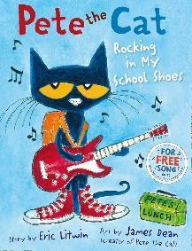  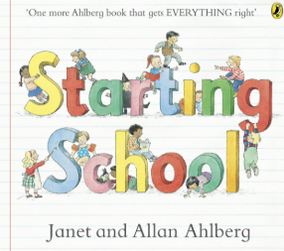 |  | 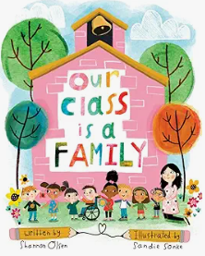  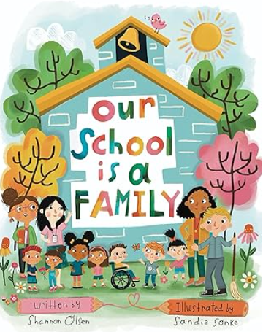 |  | 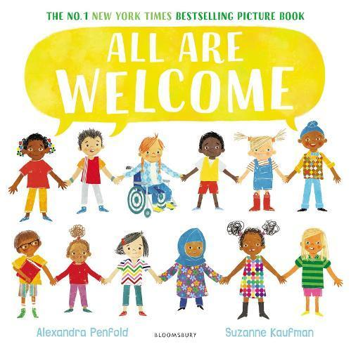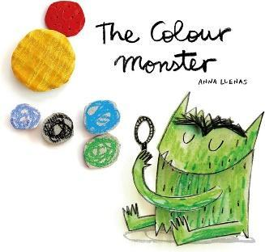 |  |  | 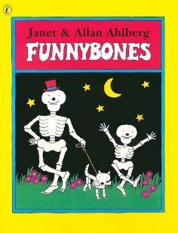 |  | 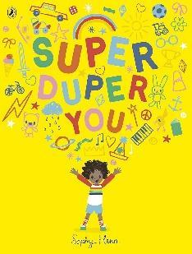 |  | 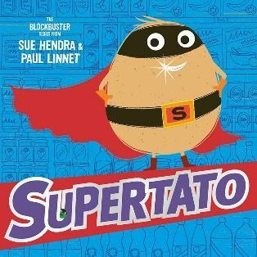  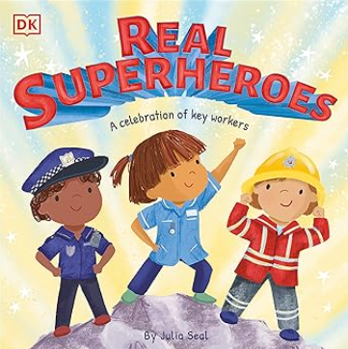
Vocab | Proud, creative, polite, school areas- classroom, Ash Tree, Hall, Playground, Library etc. |  | family, unique, respect, transition, school |  | Emotions, ownership, self-regulation, self-acceptance |  |  | Health, bones, understanding |  | Hero, personality, determined |  | Super, teamwork, co-operation, help, trust, safe, hero
EYFS Intent | Rules and routines, settling in, familiar toys and resources out. Learning about the school building, different rooms and areas in the school. |  | Our families, drawing our families, who lives in your house? Finding out more about the children. Aiding transition by explaining that our class and school are a family together. To make links to their own families at home and to share what our families are like. To create simple family trees and to learn more about each other, making connections.  Self-portraits, labelling and talking about facial expressions. |  | How can I feel different? Emotions, resilience, self-belief, learning from mistakes links to O of PROUD.  To support children’s personal, social and emotional development by helping them recognise, name, and talk about different feelings.  To develop children’s emotional vocabulary (happy, sad, angry, calm, scared, loved, mixed-up).  To encourage children to express emotions appropriately through talk, art, role play, and movement.  To build communication and language skills by discussing their own feelings and relating to the Colour Monster’s experiences.  To introduce the concept of empathy, helping children understand that others may feel differently to them.  To promote self-regulation by exploring strategies to manage big feelings (e.g., calming down, asking for help).  To nurture wellbeing and resilience, supporting children in developing confidence to share emotions in a safe environment. |  |  | How am I unique? Exploring fingerprints. How does my body work? Oral health, skeletons, bones.  How can I keep my body healthy? |  | How can I be a hero? What makes me super? WE will explore our own skills and talents and how we are unique and special. |  | Who are our real life heroes? Learning about the emergency services workers who help us in real life when we get into trouble.
EYFS Objectives | Sit at a table properly.  I correctly hold a pencil using tripod grip. |  | Sit at a table properly.  I correctly hold a pencil using tripod grip. |  | Sit at a table properly.  I correctly hold a pencil using tripod grip.  I can ascribe meaning to marks. |  |  | Sit at a table properly.  I correctly hold a pencil using tripod grip.  I can ascribe meaning to marks. |  | Sit at a table properly.  I correctly hold a pencil using tripod grip.  I can ascribe meaning to marks.  I can form lower letters correctly.  (Those taught in RWI phonics sessions) |  | Sit at a table properly.  I correctly hold a pencil using tripod grip.  I can ascribe meaning to marks.  I can form lower letters correctly.  (Those taught in RWI phonics sessions)
Autumn 2
Let’s Celebrate!
Text | 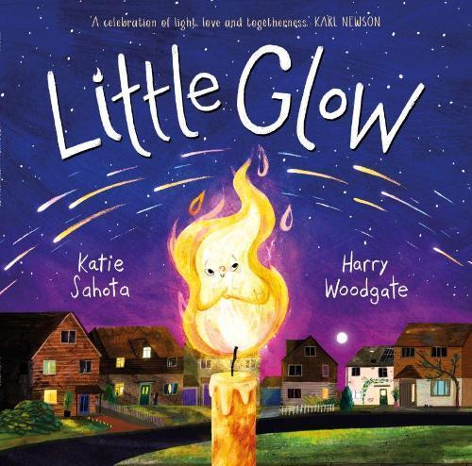  Bonfire Night 5.11.25 |  | 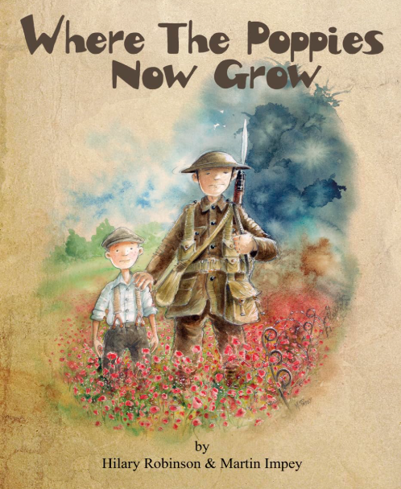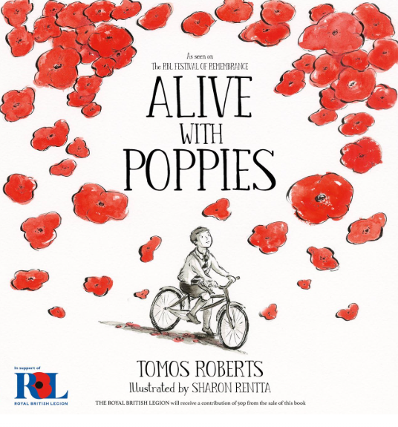  Remembrance Day 11.11.25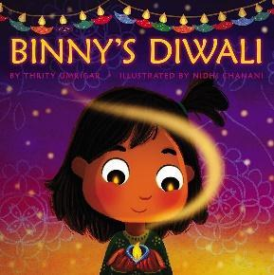Diwali: 12.11.25 |  |  |  |  | 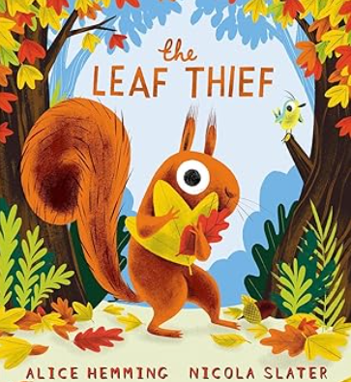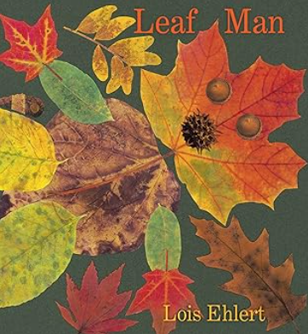 |  | 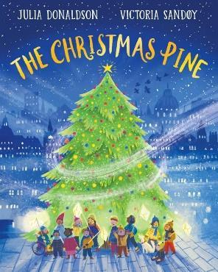 |  | 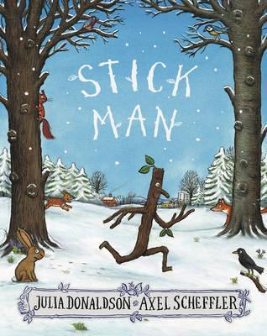  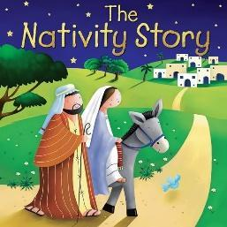
Vocab | Autumn, seasons, celebration, Bonfire Night, traditions, fireworks, safety. |  | Remembrance Day, poppy appeal, war, soldier |  | celebration, Diwali, festival, sari, Diya lamp, Hinduism, Hindu, fireworks. |  |  | Autumn, leaves, season, deciduous trees, evergreen trees. |  | Christmas, traditions, celebration |  | Christmas, nativity, Jesus
EYFS Intent | Introduce that this term is full of celebrations, begin to look through the book and work on Bonfire Night which is Wednesday this week. Look at the story of Guy Fawkes in simple terms and how it happened a long time ago and that at celebrations we have traditions which are things we do each time we have the celebration. |  | Talk about Remembrance Day and why we have and wear poppies. Talk about the importance of remembering what people have done a long time ago in the past. Mark Remembrance Day as a class. |  | Talk about what it is and different religions. Make Diya lamps and decorate. Immerse children in all things Diwali. Fireworks night comparison. Look at how light is used in different celebrations. |  |  | Talk about how the season changes from Summer to Autumn. Talk about what happens to deciduous trees and compare with evergreen trees. Talk about the feelings of the Squirrel and how his friend Bird helps him. Talk about the wind and its effects. |  | ‘Christmas comes to the home’ We learn about celebrations and Christmas traditions. Preparing for the celebration. Lists for Father Christmas. |  | The nativity story/Christmas – Nativity theme in role play. What is the real reason behind why we celebrate Christmas? How is Christmas celebrated elsewhere in the world?
EYFS Objectives | Sit at a table properly.  I correctly hold a pencil using tripod grip.  I can ascribe meaning to marks.  I can form lower letters correctly.  (Those taught in RWI phonics sessions) |  | Sit at a table properly.  I correctly hold a pencil using tripod grip.  I can ascribe meaning to marks.  I can form lower letters correctly.  (Those taught in RWI phonics sessions) |  | Sit at a table properly.  I correctly hold a pencil using tripod grip.  I can ascribe meaning to marks.  I can form lower letters correctly.  (Those taught in RWI phonics sessions)  I can write initial sounds to label pictures. |  |  | Sit at a table properly.  I correctly hold a pencil using tripod grip.  I can ascribe meaning to marks.  I can form lower letters correctly.  (Those taught in RWI phonics sessions)  I can write initial sounds to label pictures. |  | Sit at a table properly.  I correctly hold a pencil using tripod grip.  I can ascribe meaning to marks.  I can form lower letters correctly.  (Those taught in RWI phonics sessions)  I can write initial sounds to label pictures.  I can write CVC words to label pictures using a sound mat. |  | Sit at a table properly.  I correctly hold a pencil using tripod grip.  I can ascribe meaning to marks.  I can form lower letters correctly.  (Those taught in RWI phonics sessions)  I can write initial sounds to label pictures.  I can put my finger under each word to check the sounds.
Spring 1
Once Upon a Time
Text | 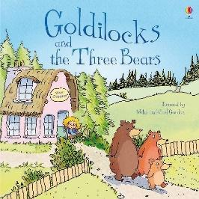 | 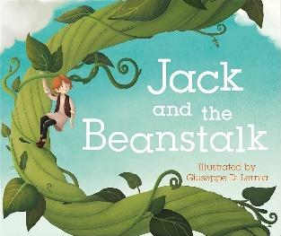  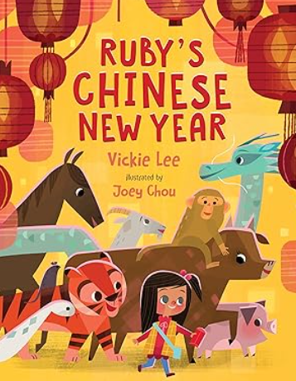 |  | 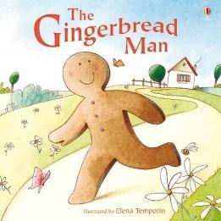 |  |  | 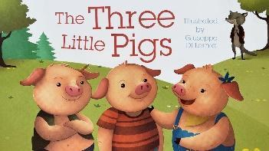 |  | 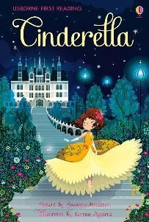 |  | 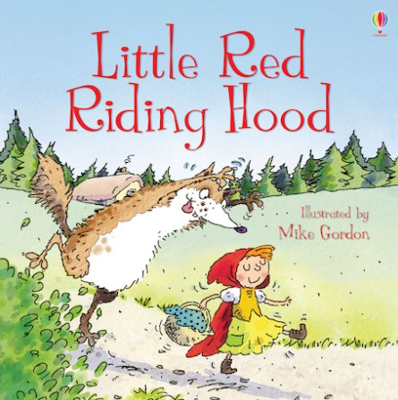
Vocab | Hot, cold, big, small, hard, soft, just right, broken, comfy, tiny | Once upon a time, tall, giant, harp |  | Gingerbread Man, Baker, Old man, Old woman, Cow, Horse, Chicken, fox, delicious, mischievous, tempting, disappear, tricked, swallowed |  |  | Big, bad, little, strong, weak, scared, safe, clever, brave, angry, loud, hot |  | Cinderella, Stepmother, Stepsisters, Fairy Godmother, Prince, King, Queen, mice, coachman, servant |  | Little Red Riding Hood, Grandma / Grandmother,  Wolf, Woodcutter, Mother,  Stranger, Red, big, bad, scary, brave, sneaky, kind, hungry, dark, quiet, clever
EYFS Intent | The children will explore the story and talk about the character points of view. They will complete drama and writing on their perspectives. | The children will learn and talk about what a fairytale is. They will explore the theme of growing using the story. |  | The children will explore baking and bake their own gingerbread men. They will also create wanted posters for the Gingerbread Man. |  |  | The children will explore what happens in the story. They will also use this as inspiration to create designs and learn the features of how to design with labels and captions. |  | The children will use the story as an inspiration for creating their own simple invitations to the ball. We will look at what an invitation must include and use that. |  | The children will explore the events of the story and each of the characters. We will discuss what LRRH did that was a mistake and how the wolf behaved. They will write wanted posters for the wolf.
EYFS Objectives | I correctly hold a pencil using tripod grip.  I can ascribe meaning to marks.  I can form lower letters correctly.  (Those taught in RWI phonics sessions)  I can write initial sounds to label pictures.  I can put my finger under each word to check the sounds. | I can think, say and remember a caption. (two or more words)  I can write a caption. |  | I can think, say and remember a caption. (two or more words)  I can write a caption. |  |  | I can think, say and remember a caption. (two or more words)  I can write a caption. |  | I can think, say and remember a caption. (two or more words)  I can write a caption. |  | I can write ccvc / cvcc words using a sound mat.  I can begin to form my letters correctly.  I can leave spaces between words.
Spring 2
Come Outside!
Text | 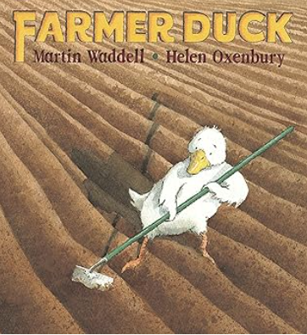 | 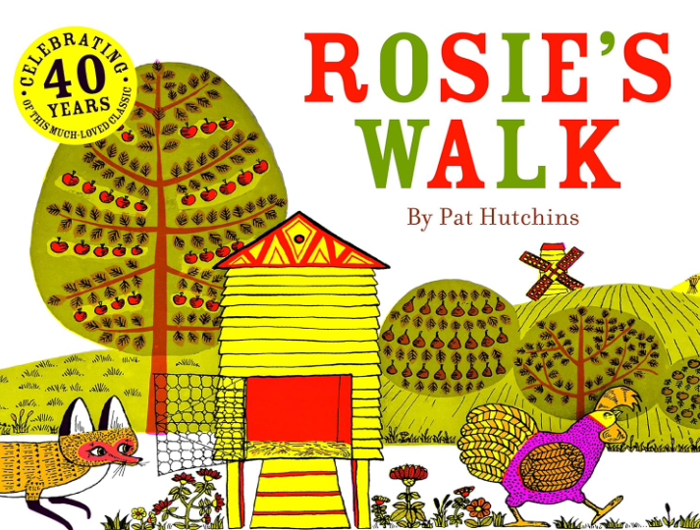 |  |  |  |  | 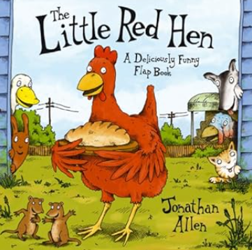 |  | 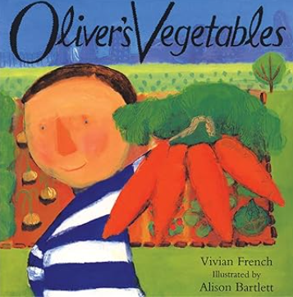
Vocab | Farmer, duck, farm, house, bed, sleep, work, field, garden, sheep, cow, hen, pig, horse | Rosie, hen, fox, farm, field, barn, yard, pond, mill, haystack. Prepositions: across, around, over, past, through, under, behind. |  |  |  |  | Hen, bread, farm, field, wheat, flour, oven, cat, dog, duck, plant, grow, cut, grind, bake, eat, help, work, carry, ask, Say / Answer |  | Oliver, Grandpa, garden, vegetable, plate, dinner, carrot, potato, cabbage, beetroot, pea, spinach, runner bean, dig, pick, plant, grow, eat, taste, try, cook, choose, find.
EYFS Intent | To support children in understanding feelings and empathy, recognising how the duck feels when he is tired and overworked, and how the animals work together to help.  Discuss the idea of fairness, teamwork, and helping others, making links to classroom rules and friendships.  Extend children’s knowledge and understanding of the world, including farm life, animal roles, and where food comes from. | Foster a love of storytelling through a simple, repetitive picture book with engaging illustrations.  Develop children’s understanding and use of positional language and prepositions (across, around, over, under, past, through, behind).  To build vocabulary linked to farms, animals, and movement. To encourage story sequencing and retelling.  To strengthen children’s spatial awareness and ability to follow and give directions.  To promote prediction skills, noticing what might happen to the fox and what Rosie does next.  To support communication and language development by encouraging children to talk about the pictures, describe events, and join in with repeated story patterns.  To nurture children’s creativity and imagination through art, movement, and outdoor activities inspired by the story.  To make meaningful links with Understanding the World, by learning about farm animals, their habitats, and the roles they play. |  |  |  |  | To foster a love of traditional tales through a repetitive, predictable story that children can join in with.  To develop children’s vocabulary linked to farming, food production, and baking.  To support children’s understanding of effort, perseverance, and fairness, recognising the value of teamwork and helping others.  To strengthen communication and language skills by joining in with repeated refrains (“Not I!”), predicting what happens next, and expressing ideas.  To build early knowledge and understanding of the world by exploring how wheat is grown, milled, and turned into bread.  To provide opportunities for hands-on learning (e.g., planting seeds, baking bread) to make meaningful links between the story and real life.  To promote personal, social and emotional development by reflecting on kindness, sharing, and the importance of helping. |  | To foster a love of stories through a simple, engaging tale with relatable characters and repeated patterns.  To develop children’s vocabulary related to vegetables, gardens, growing, and healthy eating.  To support children’s personal, social, and emotional development by exploring preferences, trying new foods, and understanding that tastes can change.  To promote communication and language skills through discussions about food, likes and dislikes, and story predictions.  To develop knowledge and understanding of the world by exploring where food comes from, how vegetables grow, and the importance of healthy eating.  To provide opportunities for hands-on learning through planting, harvesting, and cooking activities inspired by the story.  To nurture creativity through art, small-world play, and role play related to gardening and cooking.  To encourage healthy habits and curiosity about food, linking story themes to real-life experiences.
EYFS Objectives | I can write ccvc / cvcc words using a sound mat.  I can begin to form my letters correctly.  I can leave spaces between words. | I can write ccvc / cvcc words using a sound mat.  I can begin to form my letters correctly.  I can leave spaces between words. |  |  |  |  | I can write ccvc / cvcc words using a sound mat.  I can begin to form my letters correctly.  I can leave spaces between words. |  | I can write ccvc / cvcc words using a sound mat.  I can begin to form my letters correctly.  I can leave spaces between words.
Summer 1
Wonderful Wild World
Text | 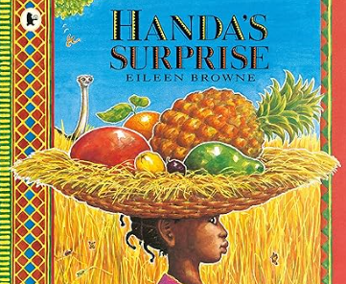 | 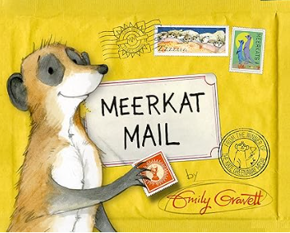 |  | 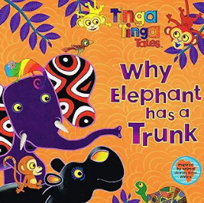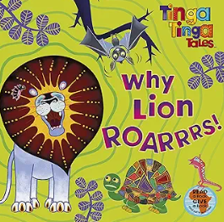 |  |  | 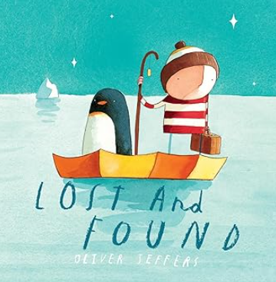 |  | 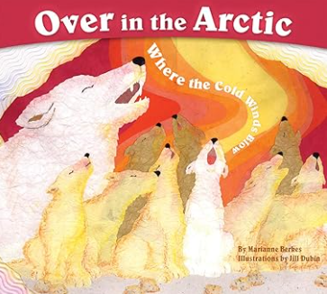 |  | 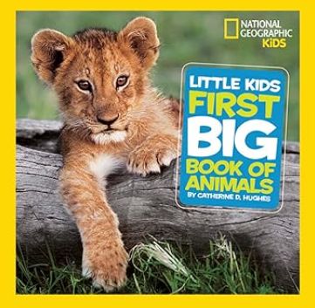
Vocab | Handa, friend, basket, surprise, village, walk, carry, banana, mango, guava, orange, avocado, passion fruit, pineapple, monkey, elephant, parrot, ostrich, goat, zebra. | Sunny, meerkat, family,  mail / post, letter, home, travel / journey, meerkat, elephant, lion, crocodile, hippo, giraffe, bird, |  | Fable, tale, animal, Forest / Jungle / Savannah (depending on the tale) Day / Night  Sun / Moon, lion, elephant, crocodile, tortoise, monkey, spider, bird, leopard |  |  | boy, penguin, boat, sea / ocean, ice, home, friend, find, lose, look, help, travel, row / sail, carry, return, walk, friend / friendship, lonely, helpful, caring, happy / sad, surprise. |  | Arctic, cold, snow, ice, wind, sky, water / sea, polar bear, walrus, seal, snowy owl, arctic fox, musk ox, whale, puffin, narwhal, hare. |  | Animal, wild / tame, big / small, habitat, food / eat, water, home, baby / young, family, collective nouns for animals, jungle, forest, ocean, desert, arctic, grassland, mountain, Mammal, Fish, Reptile,  Amphibian, Insect.
EYFS Intent | To develop children’s vocabulary linked to fruits, animals, actions, and feelings.  To support personal, social, and emotional development by exploring sharing, surprise, and friendship.  To introduce children to different cultures and environments, including African villages, landscapes, and wildlife.  To build knowledge and understanding of the world through exploring fruits, animals, and map-based activities. | To develop children’s vocabulary linked to animals, travel, journeys, and feelings.  To support personal, social, and emotional development by exploring feelings such as loneliness, excitement, and the importance of family and friendships.  To introduce children to different environments and habitats, including African savannahs, rivers, and forests.  To build knowledge and understanding of the world by exploring where animals live and how they travel. |  | To foster a love of storytelling and traditional tales through vibrant, rhythmic, and culturally rich African stories.  To develop children’s vocabulary linked to animals, actions, sounds, and descriptive language.  To support personal, social, and emotional development by exploring themes such as problem-solving, friendship, and consequences.  To introduce children to African culture and traditions, including storytelling styles, art, and music.  To build knowledge and understanding of the world by exploring animals, habitats, and folk tales from different cultures. |  |  | To develop children’s vocabulary linked to animals, journeys, the sea, and feelings.  To support personal, social, and emotional development by exploring themes of friendship, caring, helping others, and empathy.  To build knowledge and understanding of the world by exploring habitats, animals, and travel.  To nurture curiosity, observation, and problem-solving skills, encouraging children to notice details in illustrations and story patterns. |  | To develop children’s vocabulary linked to the Arctic environment, cold climates, and animals.  To encourage early counting skills through the repetitive number pattern in the text.  To build children’s knowledge and understanding of the world by exploring the Arctic habitat, how animals survive in cold climates, and environmental awareness.  To nurture personal, social, and emotional development by talking about family groups in the story and how animals care for their young.  To spark curiosity and observation skills, encouraging children to notice details about animals, numbers, and the natural world. |  | To introduce and extend vocabulary linked to animals, habitats, and descriptive features (e.g. furry, scaly, feathered).  To develop children’s knowledge and understanding of the world, exploring where animals live, what they eat, and how they survive.  To encourage children to make connections between animals and their environments (e.g. polar bears in the Arctic, camels in the desert).  To build early scientific thinking by prompting observation, comparison, sorting, and questioning.  To promote communication and language skills through discussions, asking questions, and describing animals and their actions.  To support personal, social, and emotional development by exploring themes of family groups, caring for animals, and respecting nature.  To provide opportunities for mathematical development, such as counting animal features (legs, wings), comparing sizes, and exploring patterns.
EYFS Objectives | I can use a capital letter at the start of a sentence.  I can use a full stop at the end of a sentence.  I think, say, remember and write a simple sentence using the openers The, I, He and She. | I can use a capital letter at the start of a sentence.  I can use a full stop at the end of a sentence.  I think, say, remember and write a simple sentence using the openers The, I, He and She. |  | I can use a capital letter at the start of a sentence.  I can use a full stop at the end of a sentence.  I think, say, remember and write a simple sentence using the openers The, I, He and She. |  |  | I can use a capital letter at the start of a sentence.  I can use a full stop at the end of a sentence.  I think, say, remember and write a simple sentence using the openers The, I, He and She. |  | I can use a capital letter at the start of a sentence.  I can use a full stop at the end of a sentence.  I think, say, remember and write a simple sentence using the openers The, I, He and She. |  | I can use a capital letter at the start of a sentence.  I can use a full stop at the end of a sentence.  I think, say, remember and write a simple sentence using the openers The, I, He and She.
Summer 2
At the Beach
Text | 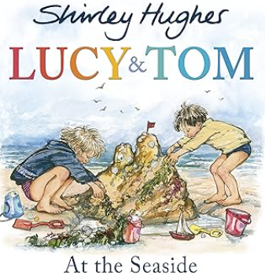 | 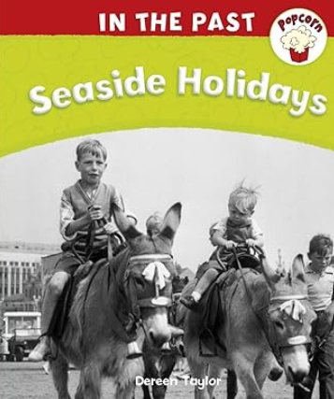 |  | 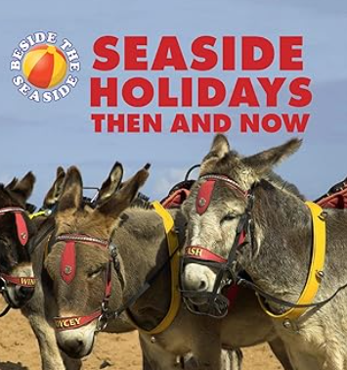 |  |  | 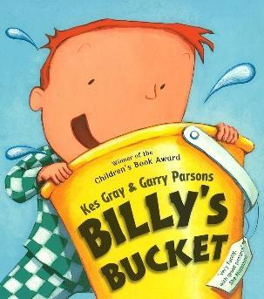 |  | 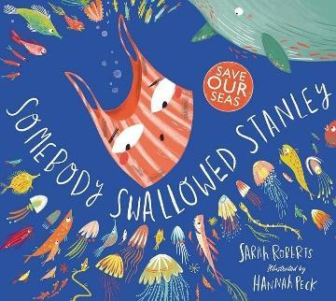 |  | 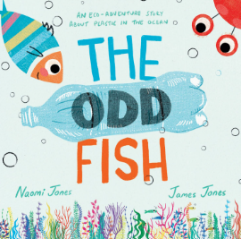
Vocab | Seaside, holiday, Lucy, Tom, Mum / Dad, beach, Sea / Ocean, Shore, bucket, spade, sandcastle, shell, rock, pebble, seaweed, towel, bathing suit / swimsuit, ice cream, picnic | past, seaside, holiday, Victorian, compare, bathing machine, donkey ride, pier, Punch and Judy, postcard, deckchair, parasol, swimsuit (old-fashioned), Tram / Train (steam train), Holiday camp |  |  |  |  | Billy, bucket, sea / ocean, beach, sand, water, boat, adventure, dig, build, swim, sail, explore, jump, look / see, play, imagine, bucket, spade, fish, crab, treasure, boat, island. |  | Reduce, reuse, recycle, pollution, plastic, litter, save, protect, wildlife, sea creatures, Stanley, ocean / sea, fish, turtle, whale, dolphin, plastic / bag / bottle / straw, trash / litter, wave / water.
EYFS Intent | To develop children’s vocabulary linked to the seaside, nature, play, and family.  To support personal, social, and emotional development by exploring themes of family, sharing, helping, and enjoying time together.  To build children’s knowledge and understanding of the world by comparing seaside holidays in the past and present, and noticing natural seaside features.  To promote communication and language development through discussion, questioning, prediction, and describing events.  To nurture curiosity and observational skills, encouraging children to notice details in illustrations and connect them with their own seaside or holiday experiences. | To foster a love of stories, discussion, and observation by exploring past and present seaside holidays.  To develop children’s vocabulary linked to seaside objects, activities, travel, and clothing across time.  To encourage comparative thinking by exploring similarities and differences between seaside holidays “then” and “now.”  To support knowledge and understanding of the world by introducing concepts of past and present, change over time, and historical objects.  To promote communication and language skills through discussion, questioning, storytelling, and describing events.  To nurture personal, social, and emotional development by reflecting on family experiences, sharing memories, and talking about what children enjoy.  To develop observation, curiosity, and critical thinking by noticing details in pictures, comparing features of holidays, and asking “why” questions. |  |  |  |  | The children begin exploring modern day seaside holidays and the creatures that live in it through the story and the boy’s magical bucket.  To develop children’s vocabulary linked to the seaside, water, adventure, and feelings.  To support personal, social, and emotional development by exploring curiosity, bravery, excitement, and friendship.  To build children’s communication and language skills through prediction, discussion, questioning, and describing events and adventures.  To develop knowledge and understanding of the world by exploring seaside features, animals, and objects (buckets, spades, boats). |  | The children will explore the issues around plastic pollution in the ocean. They will learn about the issue and write posters convincing people to reduce, reuse and recycle to protect the wildlife in the sea.  To foster a love of stories and non-fiction texts through an engaging tale with a strong environmental message.  To develop children’s vocabulary linked to oceans, sea animals, plastic pollution, and caring for the environment.  To support personal, social, and emotional development by exploring empathy for animals and the importance of helping and caring.  To develop knowledge and understanding of the world by exploring habitats, the impact of pollution, and ways to protect wildlife.  To provide opportunities for creative expression through art, role play, songs, and creating posters or models about recycling and ocean care.
EYFS Objectives | I can use a capital letter at the start of a sentence.  I can use a full stop at the end of a sentence.  I think, say, remember and write a simple sentence using the openers The, I, He and She.  I put my finger under each word to read my sentence.  I can spelI tricky words.  I can sit at a table correctly when working with an adult. | I can use a capital letter at the start of a sentence.  I can use a full stop at the end of a sentence.  I think, say, remember and write a simple sentence using the openers The, I, He and She.  I put my finger under each word to read my sentence.  I can spelI tricky words.  I can sit at a table correctly when working with an adult. |  |  |  |  | I can use a capital letter at the start of a sentence.  I can use a full stop at the end of a sentence.  I think, say, remember and write a simple sentence using the openers The, I, He and She.  I put my finger under each word to read my sentence.  I can spelI tricky words.  I can sit at a table correctly when working with an adult. |  | I can use a capital letter at the start of a sentence.  I can use a full stop at the end of a sentence.  I think, say, remember and write a simple sentence using the openers The, I, He and She.  I put my finger under each word to read my sentence.  I can spelI tricky words.  I can sit at a table correctly when working with an adult.

