Year 1/2
- All new vocabulary will be displayed on Working Walls in the classroom environment.  - WAGOLL to use for whole class teaching demonstrating the skills and vocabulary expectations. |  |  |  |  |  | - Learning is progressive and therefore texts and skills need to be taught in chronological order.  - New ambitious vocabulary will be introduced and pre taught by staff weekly using a range of adjectives, verbs, nouns, adverbs.
Autumn 1
Reading for pleasure
History – Mary Anning and Fossils |  |  |  |  |  |  | S
Text and Genre | 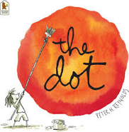 |  | 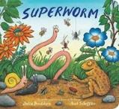  Retell – Superworm |  | Retell – What the Ladybird heard at the Seaside  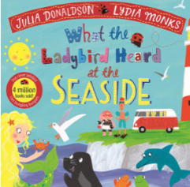 |  |  |  | Retell – Changing Tides  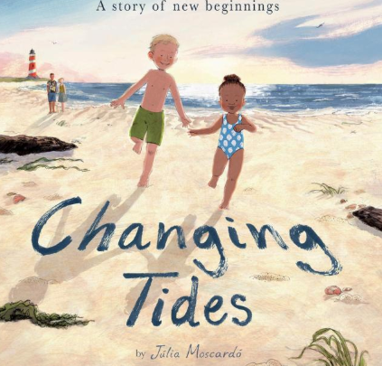 |  | Retell- Take your time - a tale of Harriet the Tortoise  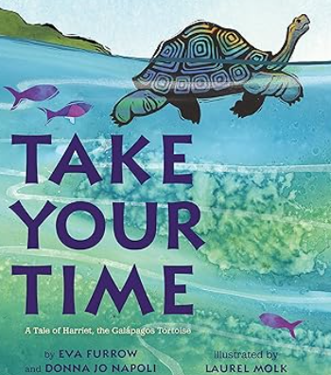 |  | Recount – Charles Darwin  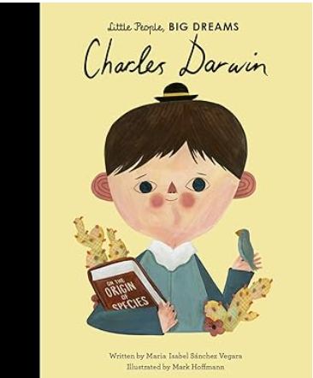
Year 1 Genre Features | Handwriting |  | Handwriting |  | Handwriting |  |  |  | Use past tense  Include beginning, middle end  Chronological order  Simple sentences  Structure needs to be correct  (Not to rewrite word for word / use said.) |  | Use past tense  Title  Include beginning, middle end  Chronological order  Story language; Once upon a time, one sunny day etc  Simple sentences  Structure needs to be correct  (Not to rewrite word for word / use said.) |  | Use past tense  Title  Include beginning, middle end  Chronological order  Story language; Once upon a time, one sunny day etc  Simple sentences  Structure needs to be correct  (Not to rewrite word for word / use said.)
Year 2 Genre Features | Handwriting |  | Description of the character and setting  No comma would be used after the fronted adverbial opener until Year 3. |  | Description of the character and setting  No comma would be used after the fronted adverbial opener until Year 3. |  |  |  | Description of the character and setting  No comma would be used after the fronted adverbial opener until Year 3. |  | Description of the character and setting  No comma would be used after the fronted adverbial opener until Year 3. |  | Description of the character and setting  No comma would be used after the fronted adverbial opener until Year 3.
Year 1  Grammar and Punctuation | Sit at a table properly and hold my pencil correctly.  I form lower case letters correctly, starting and finishing in the right place.  All letters sit on the line.  Tall letters (ascenders) touch the line above.  Use short letters.  a, c, o, d, g, q, |  | Sit at a table properly and hold my pencil correctly.  I form lower case letters correctly, starting and finishing in the right place.  All letters sit on the line.  Tall letters (ascenders) touch the line above.  Use short letters.  L, t, b, p, k, h, I, j, m, n, r, u y |  | Sit at a table properly and hold my pencil correctly.  Tall letters (ascenders) touch the line above.  Use short letters.  V,w,z,x, |  |  |  | Think, say and remember a sentence that starts with a time adverbial.  (First, Next, Finally).  Write a sentence starting with a time adverbial and ending with a full stop (fiction)  Write in the past tense. |  | Think, say and remember a sentence that starts with a time adverbial.  (First, Next, Then, After that, Finally). |  | Think, say and remember a sentence that starts with a time adverbial.  (First, Next, Then, After that, Finally).  Write a sentence starting with an opener and ending with a full stop. (She and The)  Use a capital letter for names of people.
Year 2  Grammar and Punctuation | My letters are close together when I write a word (snuggle my letters).  I fill the line with my writing.  Lower case letters are the same height. |  | Use a wider range of time adverbs at the start of my sentences.  Eg. Later that cold day, A few minutes later.  Use the past tense correctly. |  | Use a wider range of openers at the start of my sentences.  Eg. Everyone, Far away… |  |  |  | Use a wider range of question openers and end with a question mark.  Eg. Where, Who |  | Use a wider range of exciting openers and use an exclamation mark at the end of an exciting sentence.  Eg. Unexpectedly, |  | Use an expanded noun phrase (noun phrase) using one or more adjectives.
Handwriting Year 1 - Use finger spaces between words.
Handwriting Year 2 - Lower case letters are the same height. Leave equal spaces between words.
Autumn 2
Text and Genre | Retell = The Leaf Thief  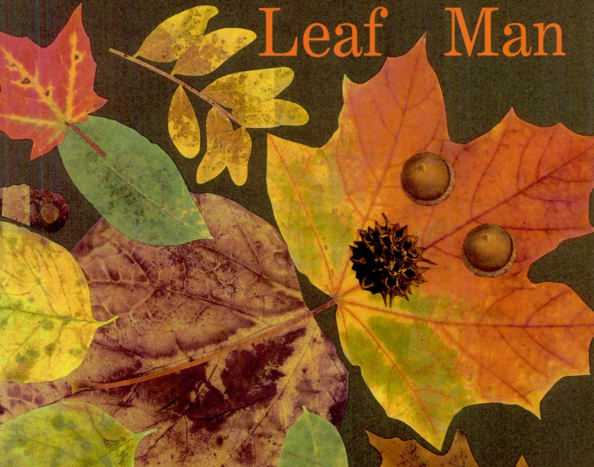 |  | Retell – The Leaf Thief  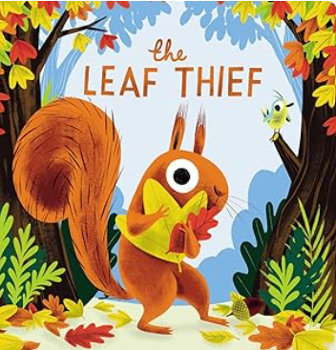 |  | Character Description – The Leaf Thief |  |  |  | Retell – Santa Trap  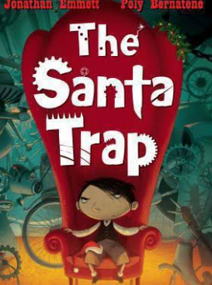 |  | Retell - Jesus Christmas Party  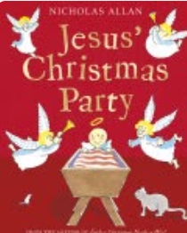 |  | Instructions to make the perfect snowman  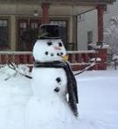
Year 1 Genre Progression | Use past tense  Include beginning, middle end  Chronological order  Simple sentences  Structure needs to be correct  (Not to rewrite word for word / use said.) |  | Use past tense  Include beginning, middle end  Chronological order  Simple sentences  Structure needs to be correct  (Not to rewrite word for word / use said.) |  | Wanted poster  Picture annotated  Name of character  What they look like  Simple adjectives (colour and size)  Appearance and personality (appropriate words) |  |  |  | Use past tense  Include beginning, middle end  Chronological order  Simple sentences  Structure needs to be correct  (Not to rewrite word for word / use said.) |  | Use past tense  Include beginning, middle end  Chronological order  Simple sentences  Structure needs to be correct  (Not to rewrite word for word / use said.) |  | Title  Numbered steps  Each step on a new line.  Time adverbial as an opener  Linked to personal experience  Present tense  Linked to oral instructions when playing
Year 2 Genre Progression | Description of the character and setting  No comma would be used after the fronted adverbial opener until Year 3. |  | Description of the character and setting  No comma would be used after the fronted adverbial opener until Year 3. |  | Separate character description  Describe how the character looks using adjectives and simple similes  Use because / when to describe their personality and actions  Use an ! in an exciting sentence  Include how other characters feel about the character I am describing. Say what I like / dislike about the character. Identify where – using prepositions Select effective vocabulary and up level. |  |  |  | Description of the character and setting  No comma would be used after the fronted adverbial opener until Year 3. |  | Description of the character and setting  No comma would be used after the fronted adverbial opener until Year 3. |  | Title with question  What you need  Introduction with a question  Command sentence / Imperative verbs as openers  -ly adverb at the start of the sentence  Top tip / warning  Link to fictional writing
Year 1  Grammar and Punctuation | Write a sentence starting with an opener and ending with a full stop. (It, He) |  | Think, say and remember a sentence that starts with a time adverbial or an opener.  Time adverbial / opener always starts with a capital letter. |  | Use adjectives to describe a noun (size and colour). |  |  |  | Write a sentence starting with an opener and ending with a full stop. (They) |  | .  AFL *  Use the conjunction ‘and’ to join two words. (The tree was tall and green). |  | Write in the present tense (instructions).  Write a sentence starting with a time adverbial and ending with a full stop (non-fiction)  AFL *
Year 1  Grammar and Punctuation | *“Dictation gives children opportunities to practise and apply their spelling knowledge and segmenting skills, without having to compose sentences by themselves. It requires them to distinguish between the sounds they hear in order to choose the correct graphemes to represent the sounds and to form the letters correctly.” Research and Review, May 2023
Year 2  Grammar and Punctuation | Use the conjunction ‘because’, ‘in fiction writing.  AFL * |  | Consolidation |  | Use commas in a list (to list adjectives in a sentence).  Use the conjunction, ‘that’ in fiction writing. |  |  |  | Use the conjunction ‘but’ |  | Use the conjunctions ‘because’, ‘that’ and ‘and’ in fiction writing.  AFL * |  | Recognise and write a command sentence with a imperative (bossy) verb and punctuate it with an exclamation mark or a full stop.  Use the present tense correctly.  Use commas in a list (to list nouns in a sentence).  Use ‘because’ and ‘and’ in non-fiction writing.  AFL *
Year 2  Grammar and Punctuation | *“Dictation gives children opportunities to practise and apply their spelling knowledge and segmenting skills, without having to compose sentences by themselves. It requires them to distinguish between the sounds they hear in order to choose the correct graphemes to represent the sounds and to form the letters correctly.” Research and Review, May 2023
Handwriting Year 1 - Form uppercase letters correctly, starting and finishing in the right place.
Handwriting Year 2 - Start using some of the diagonal strokes to join letters.
Spring 1
Science - Plants
Text and Genre | Retell – The Kapok Tree   | Diary Entry – The Kapok Tree |  | Diary -Faruq and the Wiri Wiri  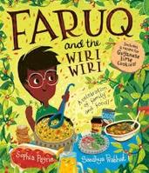 |  |  |  | Retell - The Girl Who Planted TRees  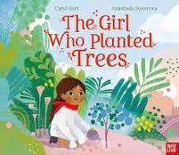 |  | Recount of The Tiny Seed   |  | List Poem  
Year 1 Genre Progression | Use past tense  Include beginning, middle end  Chronological order  Simple sentences  Structure needs to be correct  (Not to rewrite word for word / use said.) | Simple recount of a day  First person  Past tense  Dear Diary |  | Simple recount of a day  First person  Past tense  Dear Diary |  |  |  | Use past tense  Include beginning, middle end  Chronological order  Simple sentences  Structure needs to be correct  (Not to rewrite word for word / use said.) |  | Use past tense  Include beginning, middle end  Chronological order  Simple sentences  Structure needs to be correct  (Not to rewrite word for word / use said.) |  | List poem  A ‘list poem’ gets its name from the fact that most of the poem is made up of a long list of things. A  list poem usually has a few lines at the beginning, a list in the middle and a few lines at the end.
Year 2 Genre Progression | Description of the character and setting  No comma would be used after the fronted adverbial opener until Year 3. | Dear Diary and date. Add in private / secret thoughts and feelings First person (I, We, My)  Opener, Past tense  Use time adverbials to show when things happened. Chronological order and includes a rhetorical question. |  | Dear Diary and date. Add in private / secret thoughts and feelings First person (I, We, My)  Opener, Past tense  Use time adverbials to show when things happened. Chronological order and includes a rhetorical question. Informal language (contractions) |  |  |  | Description of the character and setting  No comma would be used after the fronted adverbial opener until Year 3. |  | Description of the character and setting  No comma would be used after the fronted adverbial opener until Year 3. |  | List poem  A ‘list poem’ gets its name from the fact that most of the poem is made up of a long list of things. A  list poem usually has a few lines at the beginning, a list in the middle and a few lines at the end.
Year 1  Grammar and Punctuation | Include an exclamation mark to demarcate exciting sentences (Suddenly, Quickly, As quick as a flash)  Use a capital letter for names of places. | Use the personal pronoun ‘I’  To write in the first person, I, My). |  | Use adjectives to describe thoughts and feelings (diary entry). |  |  |  | Use a question mark to demarcate a question sentence starting with Will and What. |  | Use non-fiction openers  (Some, Many, Lots, All, There)  Use capital letters for days of the week |  | -ing suffix
Year 1  Grammar and Punctuation | *“Dictation gives children opportunities to practise and apply their spelling knowledge and segmenting skills, without having to compose sentences by themselves. It requires them to distinguish between the sounds they hear in order to choose the correct graphemes to represent the sounds and to form the letters correctly.” Research and Review, May 2023
Year 2  Grammar and Punctuation | Recognise and write an exclamative sentence using What or How. | Use ‘when’ as an opener/at the start of a sentence. |  | I can use an apostrophe to show contraction in my written work. |  |  |  | Consolidate |  | Use the conjunctions ‘because’, ‘that’ and ‘and’ in non-fiction writing. |  | AFL *.
Year 2  Grammar and Punctuation | *“Dictation gives children opportunities to practise and apply their spelling knowledge and segmenting skills, without having to compose sentences by themselves. It requires them to distinguish between the sounds they hear in order to choose the correct graphemes to represent the sounds and to form the letters correctly.” Research and Review, May 2023
Handwriting Year 1 -My letters are close together when I write a word (snuggle my letters).
Handwriting Year 2 - Start using some of the horizontal strokes to join letters.
Spring 2
Geography - Weather
Text and Genre | Recount of Hook Day |   Character Description – Traction Man |  | Retell – The Smeds and Smoos  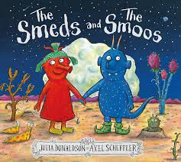 |  |  |  | 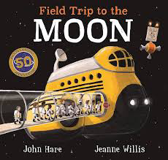  Diary – Field Trip to the Moon |  | Riddles – Fruit   |  | Riddles – Mini-beasts  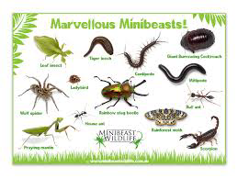
Year 1 Genre Progression | Use first person.  Use time words. Chronological.  Use information based on a real event/experience. | Wanted poster  Picture annotated  Name of character  What they look like  Simple adjectives (colour and size)  Appearance and personality (appropriate words)  Actions – what does your character do in the story?  Present tense |  | Use past tense  Include beginning, middle end  Chronological order  Simple sentences  Structure needs to be correct  (Not to rewrite word for word / use said.) |  |  |  | Simple recount of a day  First person  Past tense  Dear Diary |  | Riddle  What am I?  Openers  New clue, new line  Present tense  Conjunctions – and  Tease the reader  Adjectives |  | Riddle  What am I?  Openers  New clue, new line  Present tense  Conjunctions – and  Tease the reader  Adjectives
Year 2 Genre Progression | Chronological events  5w’s to introduce  Use proper nouns  Emotions to describe feelings (I was excited when….)  Final statement (My favourite part was…)  Details to interest the reader  Exclamative sentence to close | Present tense  Separate character description  Describe how the character looks using adjectives and simple similes  Use because / when to describe their personality and actions  Use an ! in an exciting sentence  Include how other characters feel about the character I am describing. Say what I like / dislike about the character. Identify where – using prepositions Select effective vocabulary and up level. Begin to experiment with word order in sentence structure, -ly adverbs to describe how an action was performed |  | Description of the character and setting  No comma would be used after the fronted adverbial opener until Year 3. |  |  |  | Dear Diary and date  Add in private / secret thoughts and feelings  First person (I, We, My)  Openers –  Past tense  Use time adverbials to show when things happened  Chronological order  Simple conclusion looks ahead to the future (future tense using the conjunction ‘If’) and includes a rhetorical question  Informal language (contractions) |  | Riddle  What am I?  Openers  New clue, new line  Present tense  , but  Conjunctions – and, that, When, If, or, because  Tease the reader  Commas in a list  Adjectives |  | Riddle  What am I?  Openers  New clue, new line  Present tense  , but  Conjunctions – and, that, When, If, or, because  Tease the reader  Commas in a list  Adjectives
Year 1  Grammar and Punctuation | Increase use of a variety of time adverbials (Later, Soon, At last….) | Use a wider variety of openers (On, Her, Above, Around, His, …) |  | Consoldiation |  |  |  | Use ‘and’ to join words and to join clauses in sentences. |  | Use new sentence openers - I have, I am, You (riddles). |  | Use the conjiucntion ‘and’ when wriitng a riddle.
Year 1  Grammar and Punctuation | *“Dictation gives children opportunities to practise and apply their spelling knowledge and segmenting skills, without having to compose sentences by themselves. It requires them to distinguish between the sounds they hear in order to choose the correct graphemes to represent the sounds and to form the letters correctly.” Research and Review, May 2023
Year 2  Grammar and Punctuation | Wider range of openers  E.g., In the hall,  Use an -ly adverb as an opener Slowly, Anxiously, Nervously | Use an apostrophe to show singular possession (non-fictional writing) |  | .Adding the suffix -ful (careful, fearful, powerful, dreadful, wonderful, playful, beautiful). |  |  |  | Use the conjunction ‘or’.(in a question)  Use ‘ If’ as an opener/at the start of a sentence. |  | Use a wider variety of sentence openers.  E.g., Often, Sometimes, Usaully… |  | Use the conjucntions  ‘if’, ‘and’, ‘but’, ‘When’, ‘that’, ‘or’, ‘because’ in a riddle.
Year 2  Grammar and Punctuation | *“Dictation gives children opportunities to practise and apply their spelling knowledge and segmenting skills, without having to compose sentences by themselves. It requires them to distinguish between the sounds they hear in order to choose the correct graphemes to represent the sounds and to form the letters correctly.” Research and Review, May 2023
Handwriting Year 1 - I fill the line with my writing.
Handwriting Year 2 - Start using some of the horizontal strokes to join letters.
Summer 1 –
Bounce (Start a word list of Year 2 suffixes, add to Working Wall and include in Wagolls).
Science- Exercise, Human Body
Text and Genre | 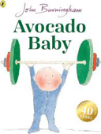  Retell – Avocado Baby | 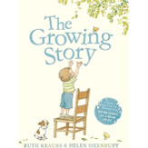  Retell – The Growing Story |  | 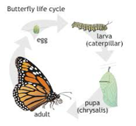  Life Cycle – Life Cycle of a butterfly |  |  |  | 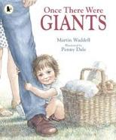  Retell - Once there were Giants |  | 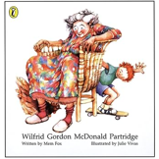  Diary - Wilfrid Gordon McDonald Partridge |  | 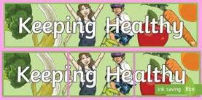  Non-Chronological Report – Keeping Healthy
Year 1 Genre Progression. | Use past tense  Include beginning, middle end  Chronological order  Simple sentences  Structure needs to be correct  (Not to rewrite word for word / use said.) | Use past tense  Include beginning, middle end  Chronological order  Simple sentences  Structure needs to be correct  (Not to rewrite word for word / use said.) |  | Present tense.  Time adverbials to sequence the process  It may be helpful if the children write an explanation which is linked to a simple life cycle. |  |  |  | Use past tense  Include beginning, middle end  Chronological order  Simple sentences  Structure needs to be correct. (Not to rewrite word for word / use said.) |  | Simple recount of a day  First person  Past tense  Dear Diary |  | Facts gathered as a class  Topic related vocabulary  Given title  Labelled pictures  Present tense
Year 2 Genre Progression | Description of the character and setting  No comma would be used after the fronted adverbial opener until Year 3. | Description of the character and setting  No comma would be used after the fronted adverbial opener until Year 3. |  | Title  Brief introduction  Scientific language  Subheadings provided by the teacher  Paragraphs  Facts and appropriate order |  |  |  | Description of the character and setting  No comma would be used after the fronted adverbial opener until Year 3. |  | Dear Diary and date  Add in private / secret thoughts and feelings. First person (I, We, My). Openers, Past tense  Use time adverbials to show when things happened. Chronological order. Simple conclusion looks ahead to the future (future tense using the conjunction ‘If’) and includes a rhetorical question  Informal language (contractions) |  | Title  Introduction  Include question  Subheadings (given)  Paragraphs (from given structure)  Ending/closing sentence  Scientific/technical language
Year 1  Grammar and Punctuation | Use est where no change is needed in the spelling of root words  (grandest, tallest, quickest) | Use –er where no change is needed in the spelling of root words |  | Use of time words in a non-fiction piece of writing.  Scientific language  Embedding all skills and layering skills within a sentence.  AFL * |  |  |  | Embed all previous skills.  AFL * |  | Embed all previous skills.  AFL * |  | Embed all previous skills in a non-fiction piece of writing
Year 1  Grammar and Punctuation | *“Dictation gives children opportunities to practise and apply their spelling knowledge and segmenting skills, without having to compose sentences by themselves. It requires them to distinguish between the sounds they hear in order to choose the correct graphemes to represent the sounds and to form the letters correctly.” Research and Review, May 2023
Year 2  Grammar and Punctuation | Add the suffix -ly to change a word from an adjective to an adverb and use as a sentence openers. | To use effective word choices and create a list of adjectives to describe a noun. |  | AFL * |  |  |  | AFL * |  | Use a comma to separate adjectives when describing a noun. |  | Use an apostrophe to show singular possession.  AFL *
Year 2  Grammar and Punctuation | *“Dictation gives children opportunities to practise and apply their spelling knowledge and segmenting skills, without having to compose sentences by themselves. It requires them to distinguish between the sounds they hear in order to choose the correct graphemes to represent the sounds and to form the letters correctly.” Research and Review, May 2023
Handwriting Year 1 - Fill the line with writing and start a new line when there is not enough space to write the complete word.
Handwriting Year 2 - Start to join handwriting.
Summer 2
Scented Garden
Science –Plants
Text and Genre | Instructions to plant a seed   | Retell – The Girl Who Planted Trees |  | 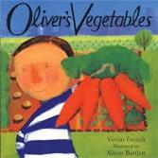  Informal Letter – Oliver’s Vegetables |  |  |  | Retell – Faruq and the Wirir Wiri |  | Retell – The Enormous Turnip  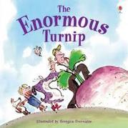 |  | Acrostic Poem –
Year 1 Genre Progression | Title  Numbered steps  Each step on a new line  What you need with bullet points  Time adverbial as an opener  Linked to personal experience  Present tense  Linked to oral instructions when playing | Use past tense  Include beginning, middle end  Chronological order  Simple sentences  Structure needs to be correct  (Not to rewrite word for word / use said.) |  | Simple format (To, From)  First person  An informal greeting (Hi)  Add a few sentences  First sentence starts on a new line  From on a new line and add my name |  |  |  | Use past tense  Include beginning, middle end  Chronological order  Simple sentences  Structure needs to be correct  (Not to rewrite word for word / use said.) |  | Use past tense  Include beginning, middle end  Chronological order  Simple sentences  Structure needs to be correct  (Not to rewrite word for word / use said.) |  | Acrostic poem using adjectives
Year 2 Genre Progression | Title with question  What you need  Introduction with a question  Command sentence / Imperative verbs as openers  -ly adverb at the start of the sentence  Top tip / warning  Link to fictional writing | Description of the character and setting  No comma would be used after the fronted adverbial opener until Year 3. |  | Address and date (Given)  Greeting (From a choice)  Past tense  Introduction (why you are writing)  More details  Final sentence written in the present tense (what the sender wants the recipient to do next)  Signing off (given)  Personal thoughts and feelings  Informal (use contractions) |  |  |  | Description of the character and setting  No comma would be used after the fronted adverbial opener until Year 3. |  | Description of the character and setting  No comma would be used after the fronted adverbial opener until Year 3. |  | Acrostic poem using adjectives
Year 1  Grammar and Punctuation | Including a ‘You will need subheading’.  Using a time adverbial at the start of a sentence.  Using the conjunction ‘and’ for instructional writing. | Focus on using the question words – Where and Who to begin a question sentence. |  | Consolidation of capital letters for day of the week. |  |  |  | AFL * |  | AFL * |  | *Adding the endings –ing, verbs where no change is needed to the root word for (hunting, buzzing, buzzed, buzzer, jumping).
Year 1  Grammar and Punctuation | *“Dictation gives children opportunities to practise and apply their spelling knowledge and segmenting skills, without having to compose sentences by themselves. It requires them to distinguish between the sounds they hear in order to choose the correct graphemes to represent the sounds and to form the letters correctly.” Research and Review, May 2023
Year 2  Grammar and Punctuation | Embedding all skills and layering skills within a sentence.  AFL *  Use a variety of openers.  Time adverbial,  Imperative verbs and adverbs.  Use the conjunction ‘if’ to include a top tip.  You the conjunction ‘or’ for instructional writing. | Embedding all skills and layering skills within a sentence.  AFL * |  | Write in the progressive past tense. |  |  |  | Embedding all skills and layering skills within a sentence.  AFL * |  | Embedding all skills and layering skills within a sentence. |  | Write in the progressive present tense.
Year 2  Grammar and Punctuation | *“Dictation gives children opportunities to practise and apply their spelling knowledge and segmenting skills, without having to compose sentences by themselves. It requires them to distinguish between the sounds they hear in order to choose the correct graphemes to represent the sounds and to form the letters correctly.” Research and Review, May 2023
Handwriting Year 1 - Fill the line with writing and start a new line when there is not enough space to write the complete word.
Handwriting Year 2 - Start to join handwriting.

Informal Letter | Retell | Diary | Setting | Persuasive Letter | Character description
Simple format (To, From)  First person  An informal greeting (Hi)  Add a few sentences  First sentence starts on a new line  From on a new line and add my name  For example, from Goldilocks to the bears  Date | Use past tense  Title  Include beginning, middle end  Chronological order  Story language; Once upon a time, one sunny day etc  Simple sentences  Structure needs to be correct  (Not to rewrite word for word / use said.) | Simple recount of a day  First person  Past tense  Dear Diary | Use senses (see and hear) to compile a word bank of adjectives to describe setting through visual stimulus  First person  Present tense | N/A | Wanted poster  Picture annotated  Name of character  What they look like  Simple adjectives (colour and size)  Appearance and personality (appropriate words)  Actions – what does your character do in the story?  Present tense
Explanation | Biography | Non-chron. | Newspaper | Instructions | Recount
Present tense.  Time adverbials to sequence the process  It may be helpful if the children write an explanation which is linked to a simple life cycle. | N/A | Facts gathered as a class  Topic related vocabulary  Given title  Labelled pictures  Present tense | N/A | Title  Numbered steps  Each step on a new line  What you need with bullet points  Time adverbial as an opener  Linked to personal experience  Present tense  Linked to oral instructions when playing | Use first person.  Use time words. Chronological.  Use information based on a real event/experience.
Formal Letter
N/A

Informal Letter | Retell | Diary | Setting | Persuasive Letter | Character description
Address and date (Given)  Greeting (From a choice)  Past tense  Introduction (why you are writing)  More details  Final sentence written in the present tense (what the sender wants the recipient to do next)  Signing off (given)  Personal thoughts and feelings  Informal (use contractions) | May create a story map or use pictures as prompts  Description of the character and setting  No comma would be used after the fronted adverbial opener until Year 3. | Dear Diary and date  Add in private / secret thoughts and feelings  First person (I, We, My)  Openers –  Past tense  Use time adverbials to show when things happened  Chronological order  Simple conclusion looks ahead to the future (future tense using the conjunction ‘If’) and includes a rhetorical question  Informal language (contractions) | Describe using the senses – what the character can see, hear, smell, touch and how they feel  Identify where – using prepositions  Similes  Expanded Noun Phrase  Range of openers (Far away, In the distance)  Past tense  If the setting writing is part of a story, rhetorical questions relating to the characters may be asked. |  | Present tense  Separate character description  Describe how the character looks using adjectives and simple similes  Use because / when to describe their personality and actions  Use an ! in an exciting sentence  Include how other characters feel about the character I am describing  Say what I like / dislike about the character. Identify where – using prepositions Select effective vocabulary and up level. Begin to experiment with word order in sentence structure, -ly adverbs to describe how an action was performed
Explanation | Biography | Non-chron. | Newspaper | Instructions | Recount
Title  Brief introduction  Scientific language  Subheadings provided by the teacher  Paragraphs  Facts and appropriate order | N/A | Title  Introduction  Include question  Subheadings (given)  Paragraphs (from given structure)  Ending/closing sentence  Scientific/technical language | N/A | Title with question  What you need  Introduction with a question  Command sentence / Imperative verbs as openers  -ly adverb at the start of the sentence  Top tip / warning  Link to fictional writing | Chronological events  5w’s to introduce  Use proper nouns  Emotions to describe feelings (I was excited when….)  Final statement (My favourite part was…)  Details to interest the reader  Exclamative sentence to close
Formal Letter
Address and date (Given)
Greeting (From a choice)
Past tense
Introduction (why you are writing)
Final sentence
Signing off (given)
Thank you, letter, following a school trip / visitor

