
KS1 Homework Menu

Spring 1 – Bright Lights, Big City!
Take a trip to London and explore all of the different landmarks you can see. Visit Monument to find out more about the Great Fire of London. | 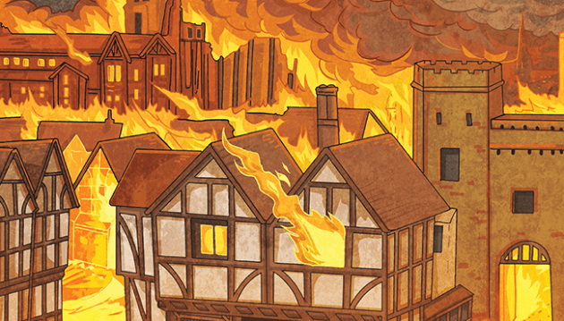  Create a piece of art to represent the Great Fire of London. You could paint, draw or even use collage! |   Learn about a famous landmark in London. Can you create a fact file to share what you have learnt?
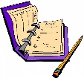  Imagine you are a modern day Samuel Pepys. Can you keep a diary like he did during the Great Fire of London? | 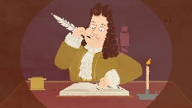  If you were Samuel Pepys, what would you have buried in your garden during the Great Fire and why? | 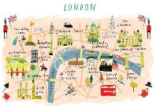  Explore Google Earth to see London from above. Can you create your own map of the city?
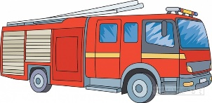  Create a fire safety poster to help other people in our community. | Find out all about the Great Fire of London and create your own information text or book! |   Imagine you are Thomas Farriner and bake some bread to share with your family.
Homework Due: Monday 19th February 2024

Select three activities from this half term’s menu to complete.

You can present your work in any way you wish; drawings, computer based, posters, stories.
Be creative!

Bring your homework in on the first day back after the February half term where we will share all of our fantastic work as a key stage!

If you need any resources or help, talk to your class teacher.

